Name

Mathematics Stage 5 Core
Quadratic & Exponential Relationships

Book 1 | Plot Quadratics and Exponentials  Features of Quadratics and Exponentials | Version: 260726  Feedback:  https://MrDingMaths.com
Contents
Syllabus Content 2
Quadratic Relationships 3
Properties of the Parabola 8
Basic Transformations of the Parabola 12
Exponential Relationships 16
Properties of the Exponential Curve 19
Basic Transformations of the Exponential Curve 22
Comparing Relationships 27
Quadratic Modelling 33
Exponential Modelling 40

Syllabus Content
MA5-NLI-C-01 identifies connections between algebraic and graphical representations of quadratic and exponential relationships in various contexts
Examine the connection between algebraic and graphical representations of quadratics and exponentials
- Represent quadratic and exponential relationships using graphing applications
- Construct a table of values to graph non-linear relationships involving quadratics and exponentials
- Explain that quadratic relationships are represented by parabolas
- Identify graphs and equations of parabolas and exponential curves
- Recognise quadratics and exponentials in real-life contexts
Graph and examine quadratic relationships
- Graph and compare parabolas of the form $y={kx}^{2}$ and $y={kx}^{2}+c$ using graphing applications
- Identify and describe the key features of parabolas of the form $y={kx}^{2}$ and $y={kx}^{2}+c$ including the vertex, $x$- and $y$-intercepts, axis of symmetry and concavity
Graph and examine exponential relationships
- Graph and compare exponential curves of the form $y=a^{x}$ using graphing applications
- Describe features of exponential curves including the $y$-intercept, asymptote and the nature of the curve for very large and very small values of $x$
Distinguish between linear, quadratic and exponential relationships by examining their graphical representations
- Associate graphs of straight lines, parabolas and exponential curves with the appropriate equations
- Recognise non-linear relationships in real-life contexts and solve related problems
- Use graphing applications to solve a pair of simultaneous equations where one equation is non-linear and interpret the solution

Quadratic Relationships

- Review
- Evaluate quadratic expressions
- $4^{2}$ | - ${\left(-4\right)}^{2}$ | - $\left(-4^{2}\right)-3\left(-4\right)+1$

- Substitute into quadratic equations
- Substitute $x=3$ into  $$y=x^{2}+2x-4$$ | - Substitute $x=-2$ into  $$y=x^{2}-2x+5$$ | - Substitute $x=3$ into  $$y=\frac{x^{2}}{2}-5$$

- Quadratic Relationships
Linear relationships are in the form $y=mx+c$.
The graph is a straight line; so, the relationship is linear.
Quadratic relationships are in the form $y=ax^{2}+bx+c$.
Their graph will not be a straight line; so the relationship is non-linear.
We can graph quadratic relationships the same way as linear relationships:
  - Construct a table of values using the equation.
  - Graph the table by using the columns as coordinates.
  - Join the points to form a smooth curve.

- Investigation Graph quadratic relationships using a table of values
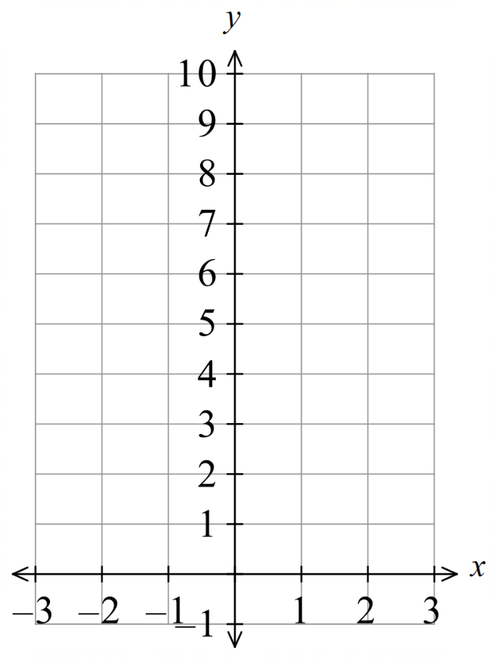
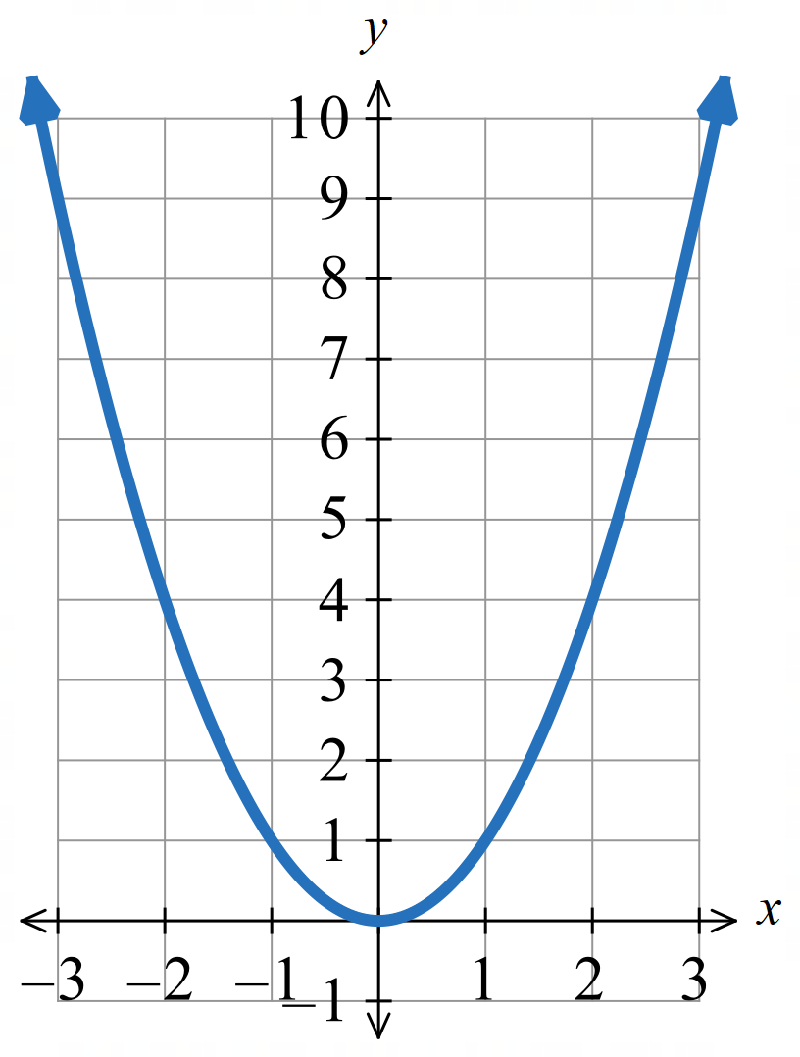
Draw the graph of $y=x^{2}$
$$x$$ | $$-3$$ | $$-2$$ | $$-1$$ | $$0$$ | $$1$$ | $$2$$ | $$3$$
$$y$$

Draw the graph of $y=x^{2}-4$
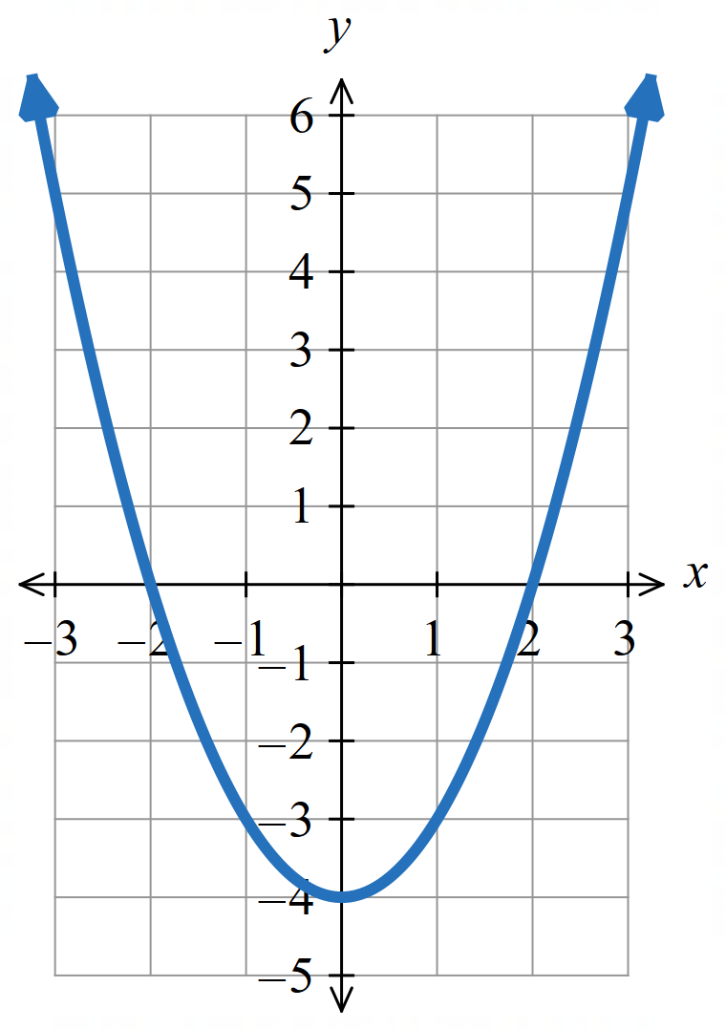
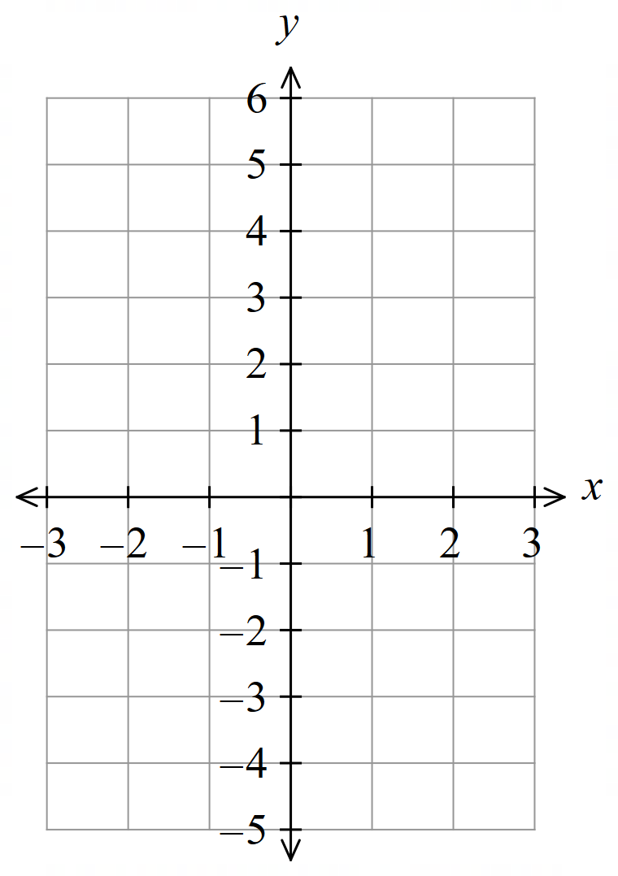

$$x$$ | $$-3$$ | $$-2$$ | $$-1$$ | $$0$$ | $$1$$ | $$2$$ | $$3$$
$$y$$

Foundation
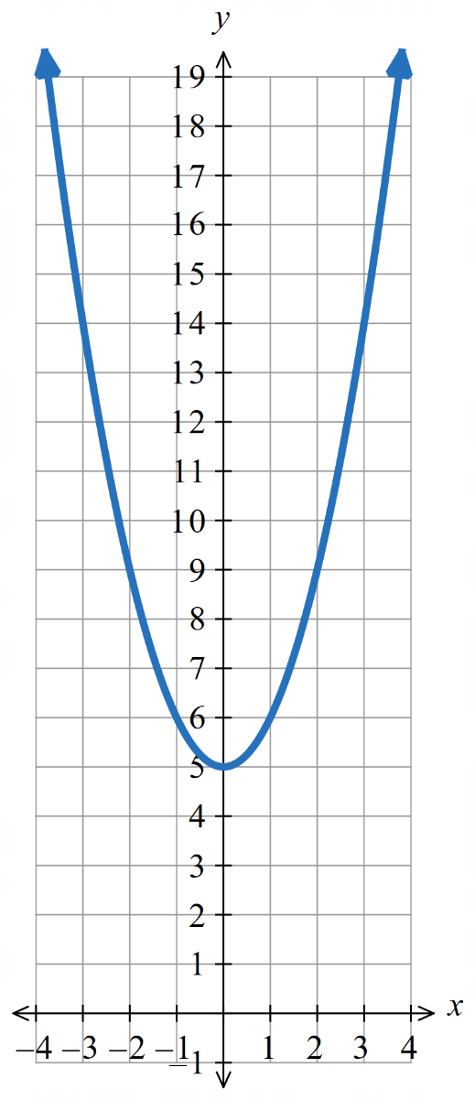
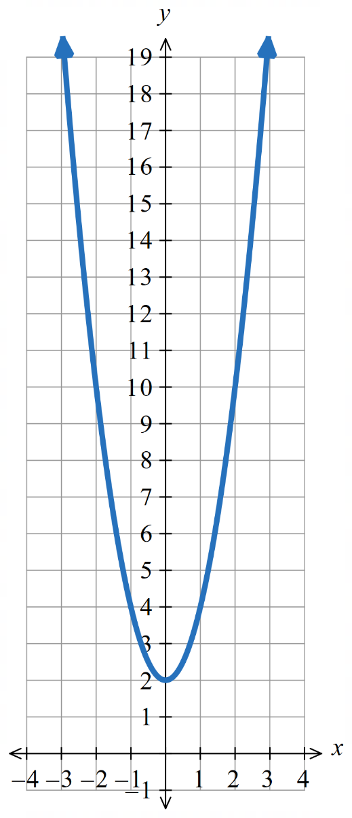
- Sketch these parabolas.
- $y=x^{2}+5$ | - $y=2x^{2}+2$ | 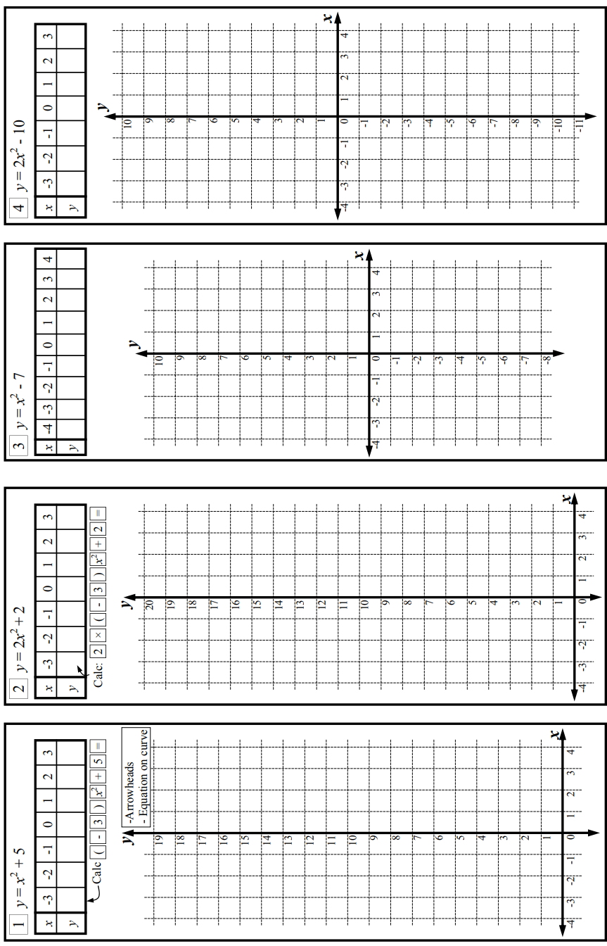  - $y=x^{2}-7$  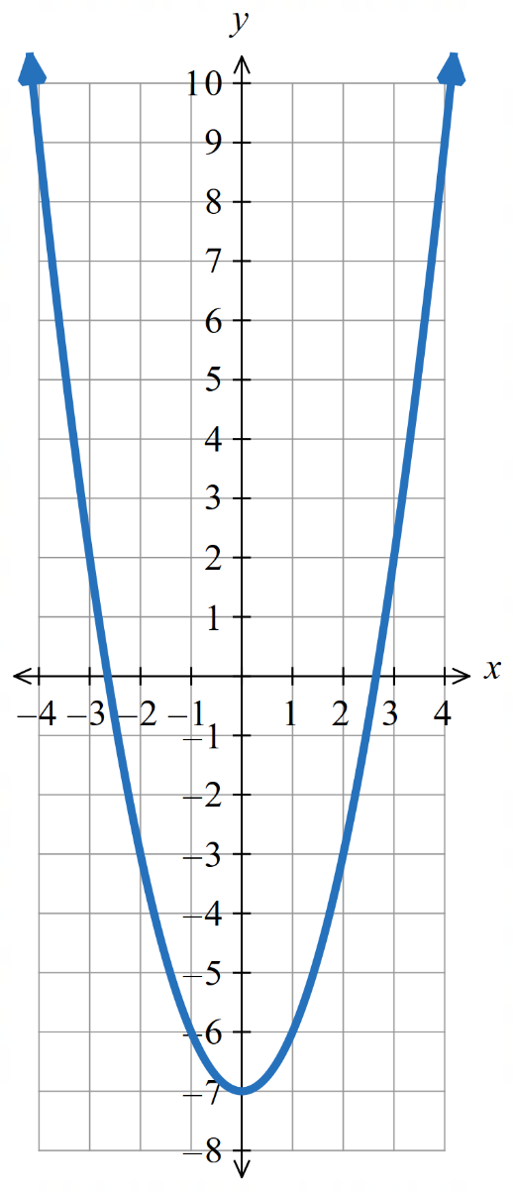  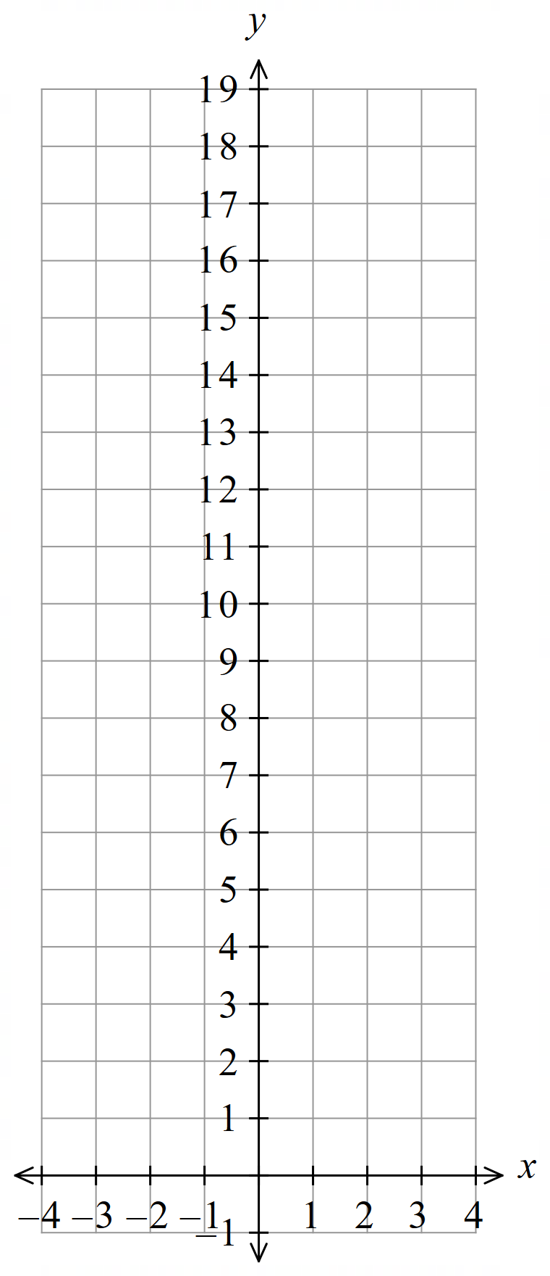  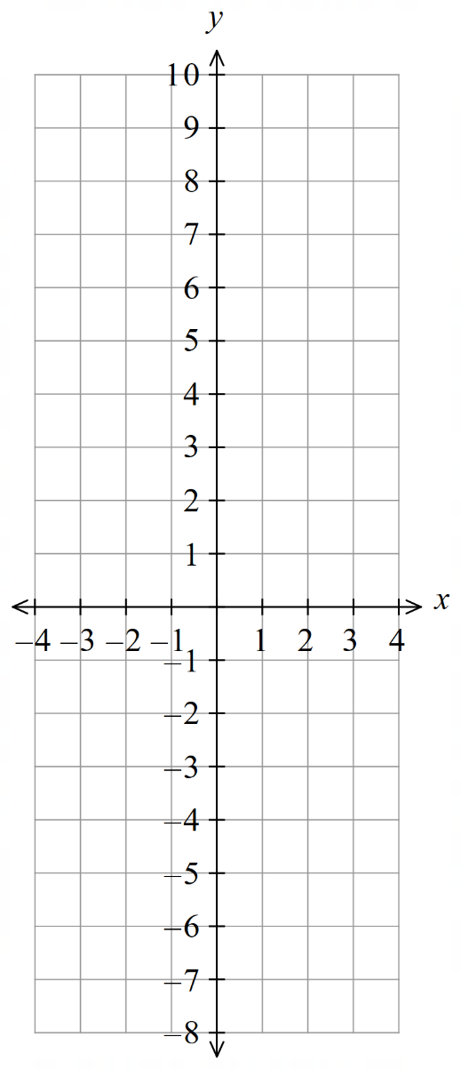  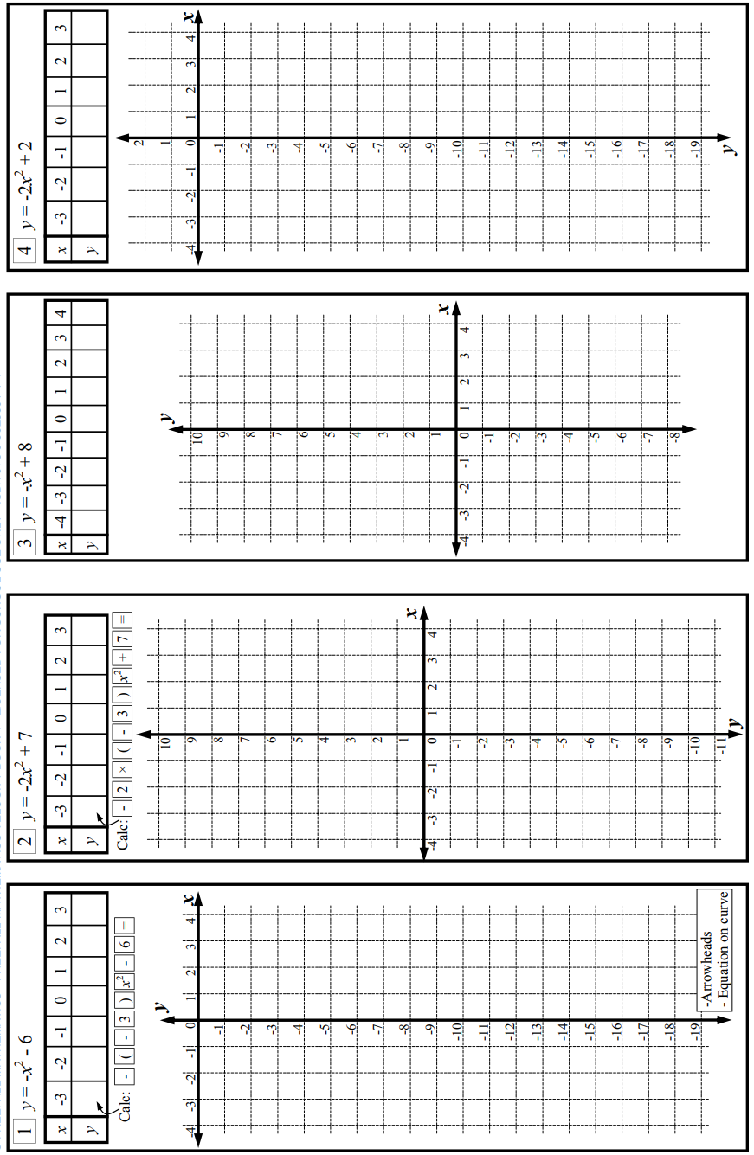
- $y=-x^{2}-6$ | - $y=-2x^{2}+7$ | - $y=-x^{2}+8$  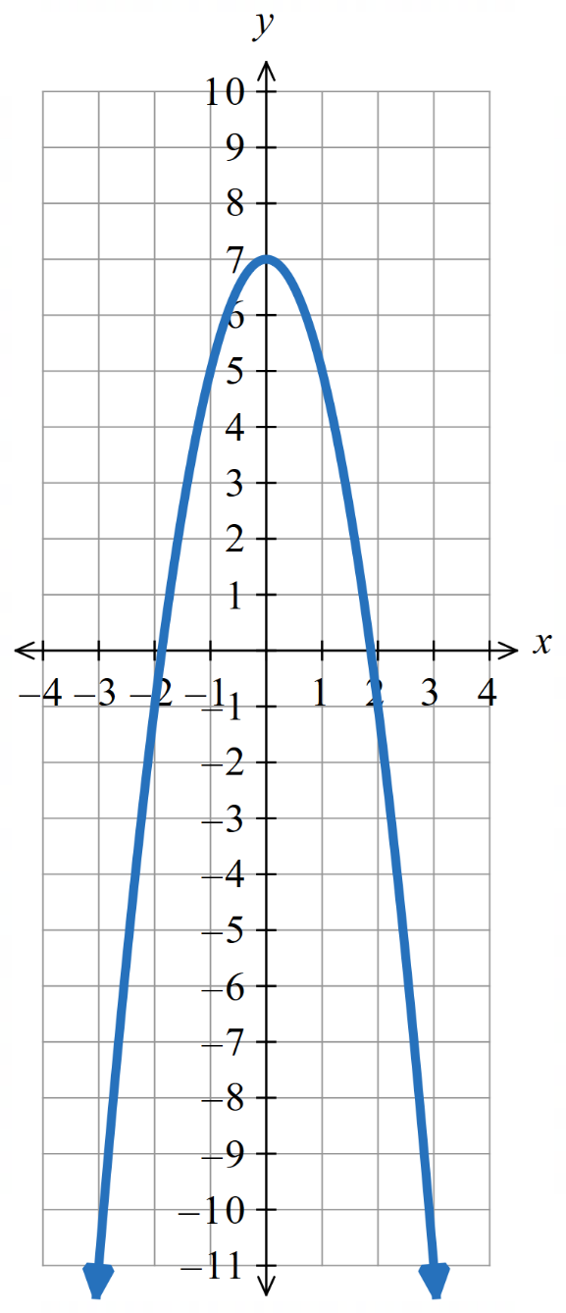  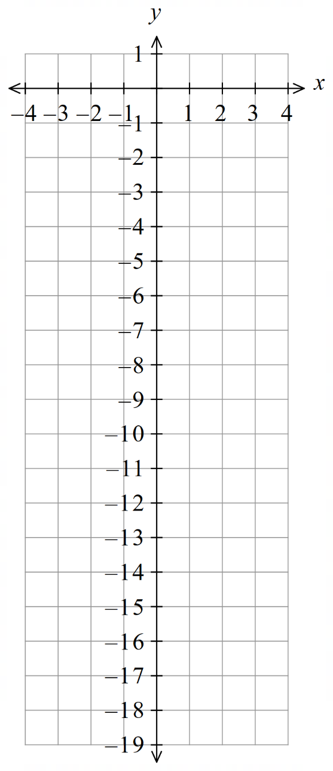  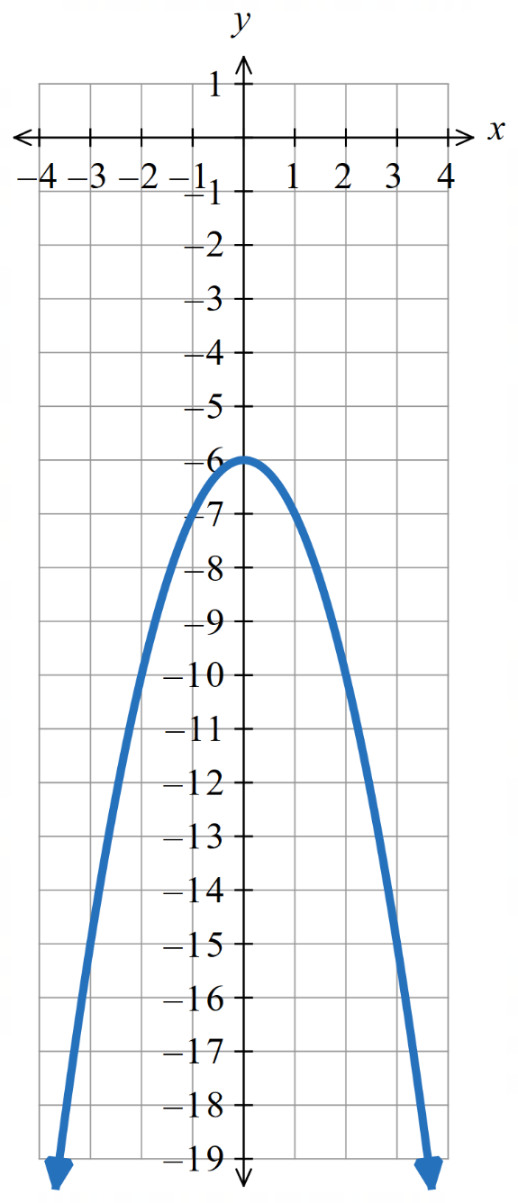  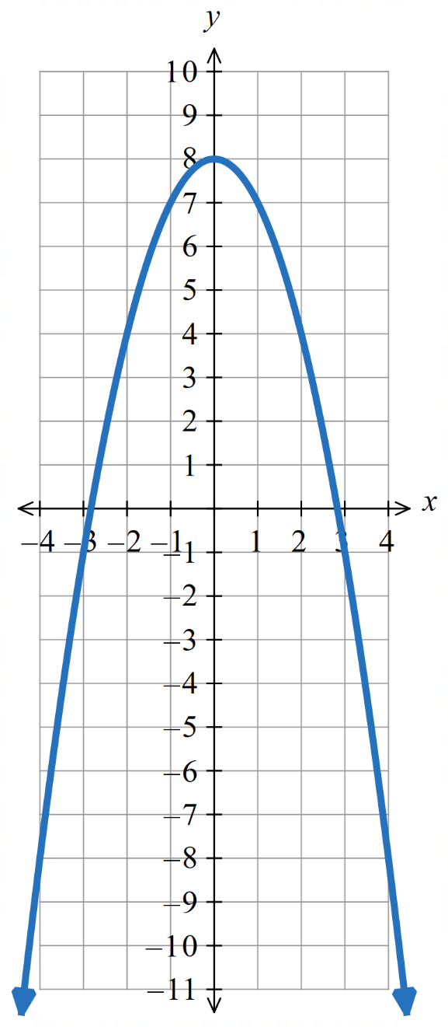  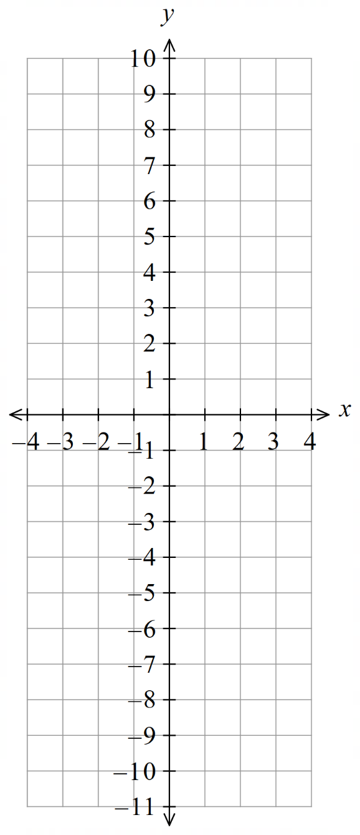
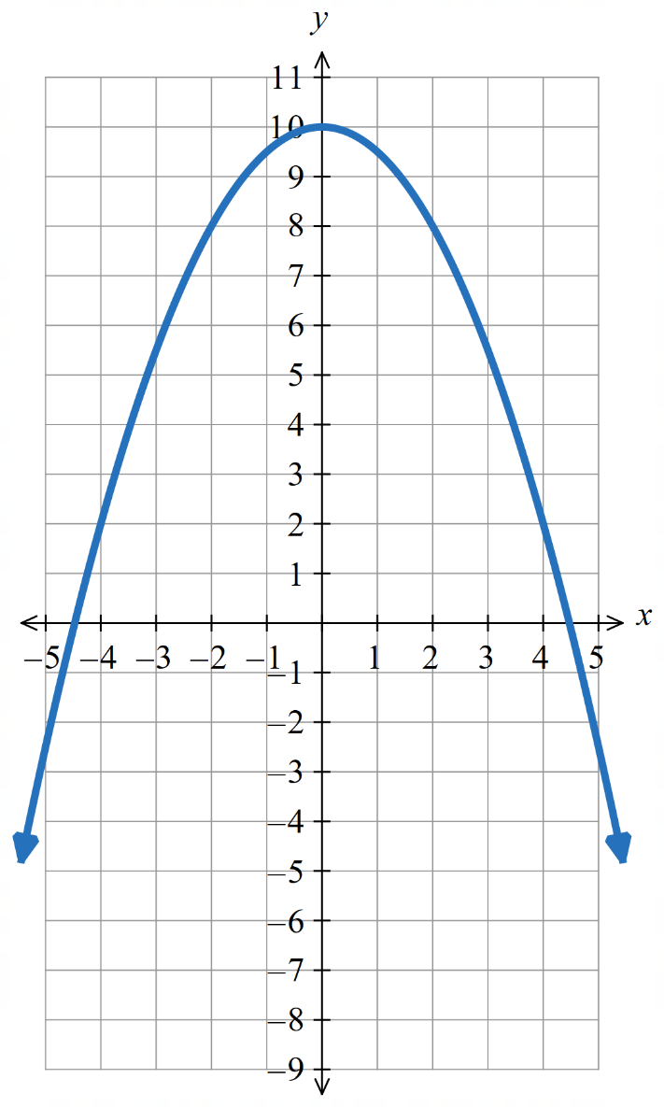
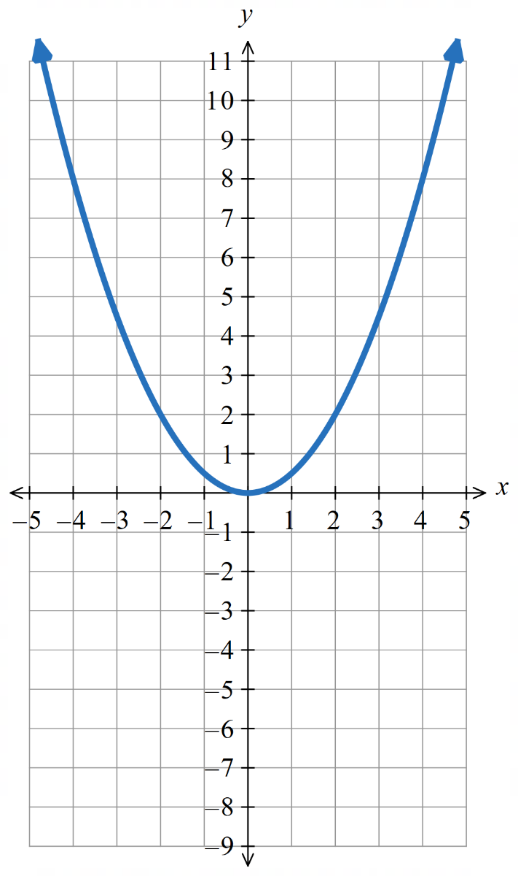
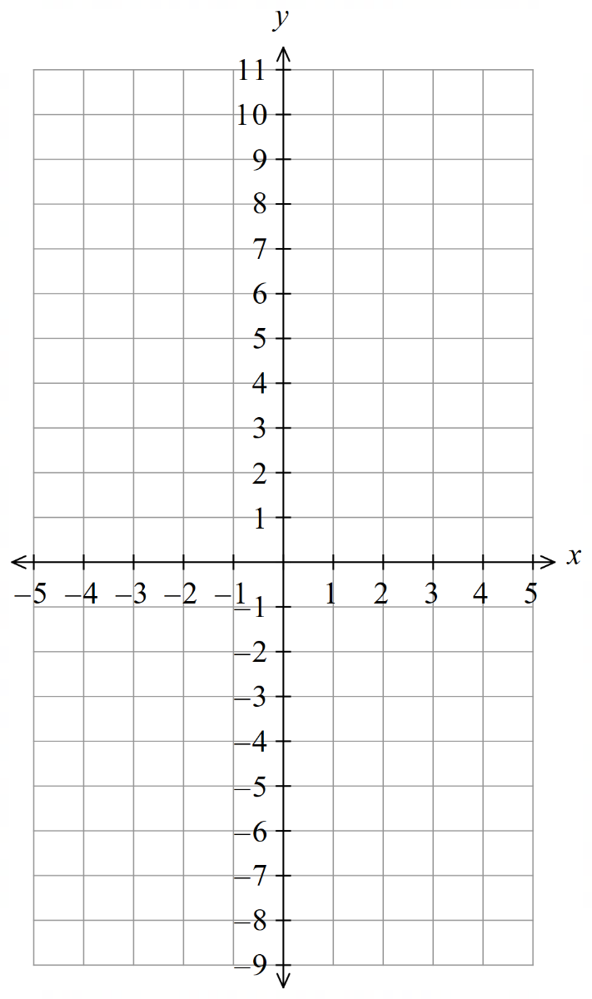
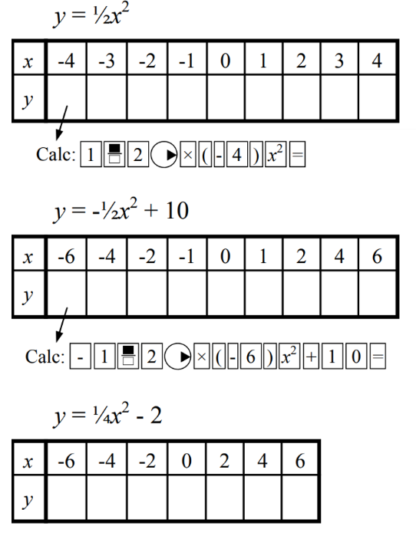
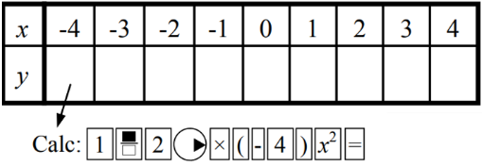
- Sketch these graphs.
- $y=\frac{1}{2}x^{2}$ | - $y=-\frac{1}{2}x^{2}+10$ | - $y=\frac{1}{4}x^{2}-2$  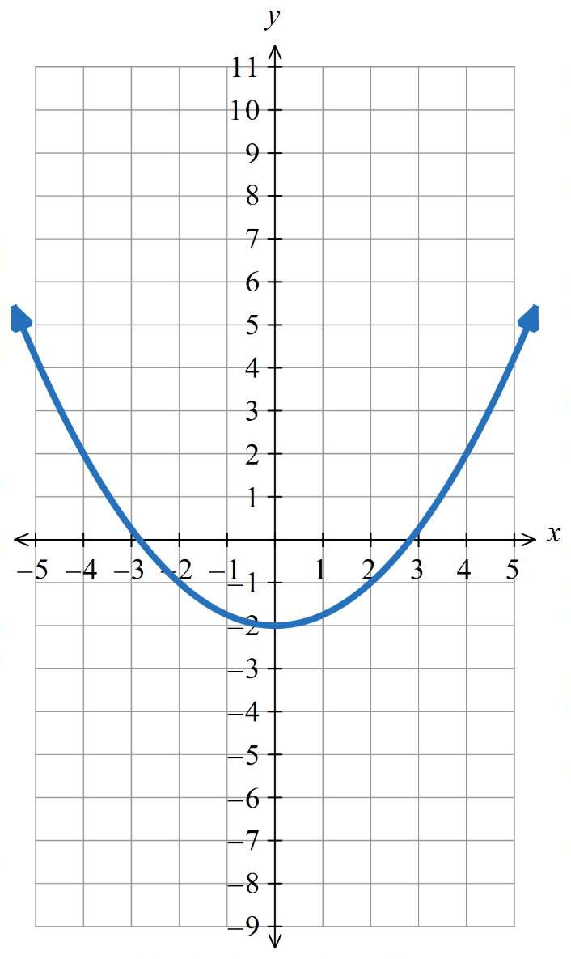

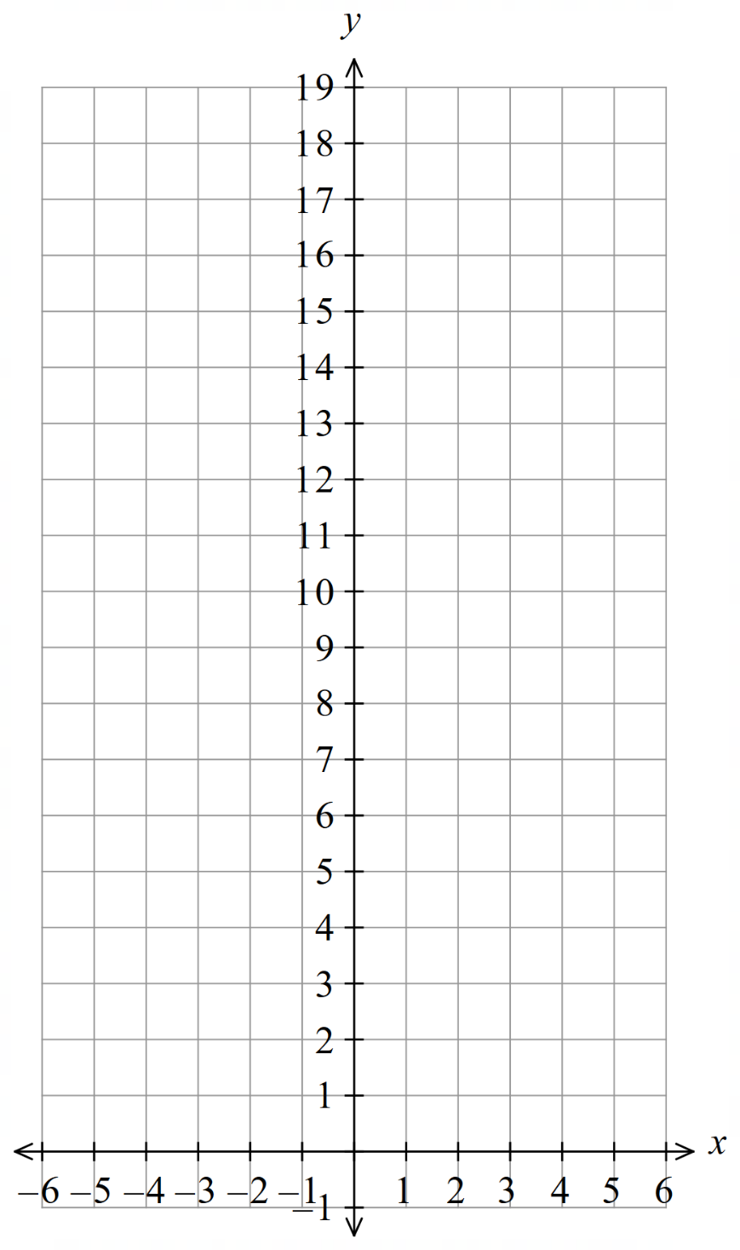
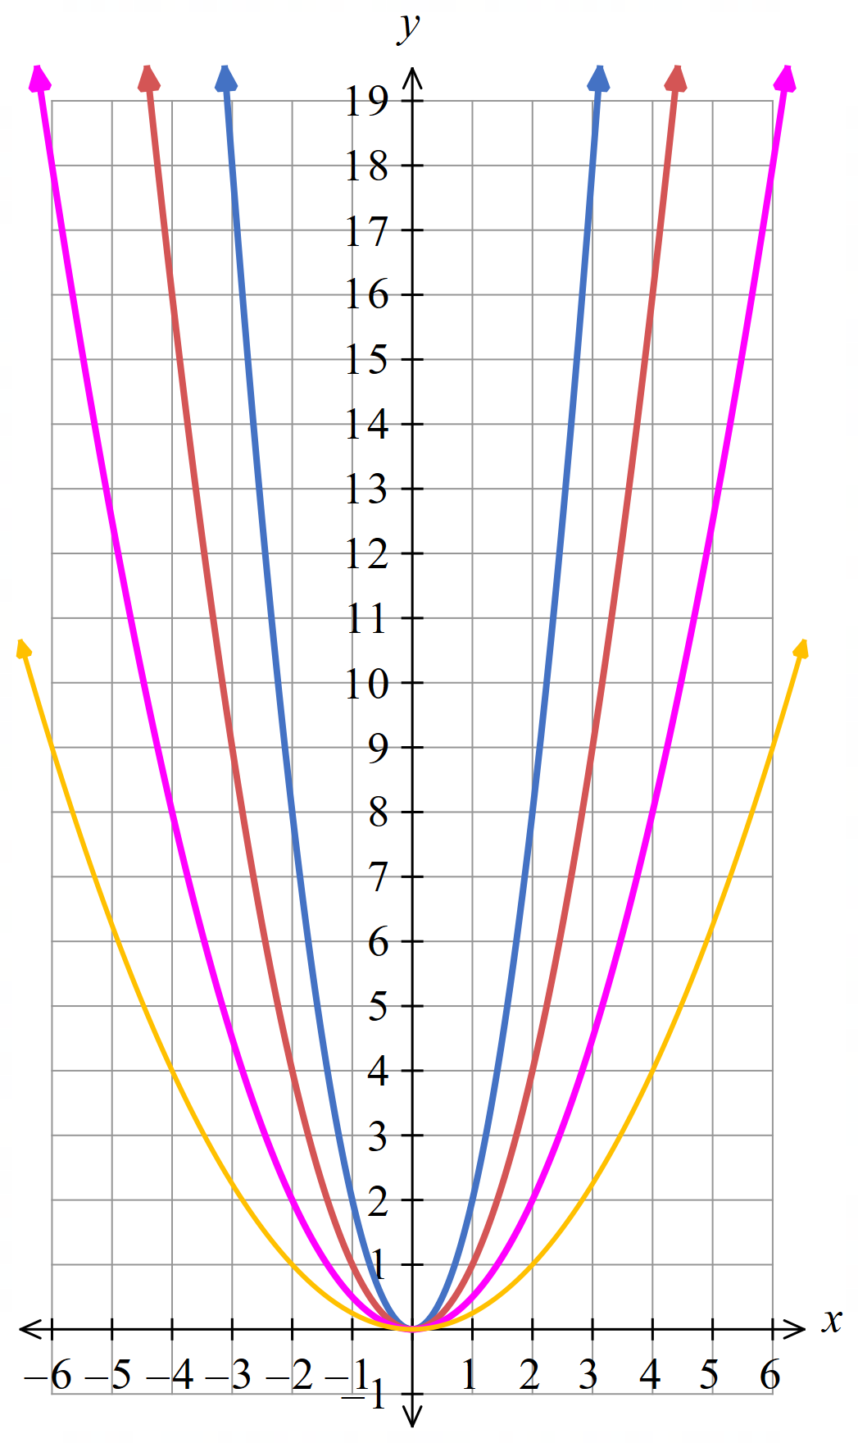
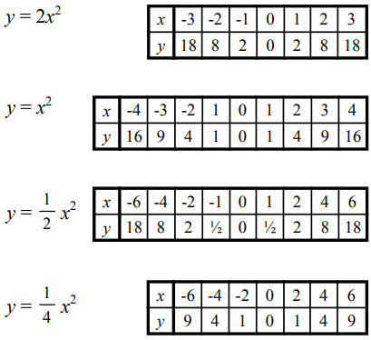
- Plot these on the same axis and label each parabola.

Circle the correct option:
As the coefficient of $x^{2}$ increases, the parabola gets:
- Wider
- Narrower
Narrower
- Plot these on the same axis and label each parabola.
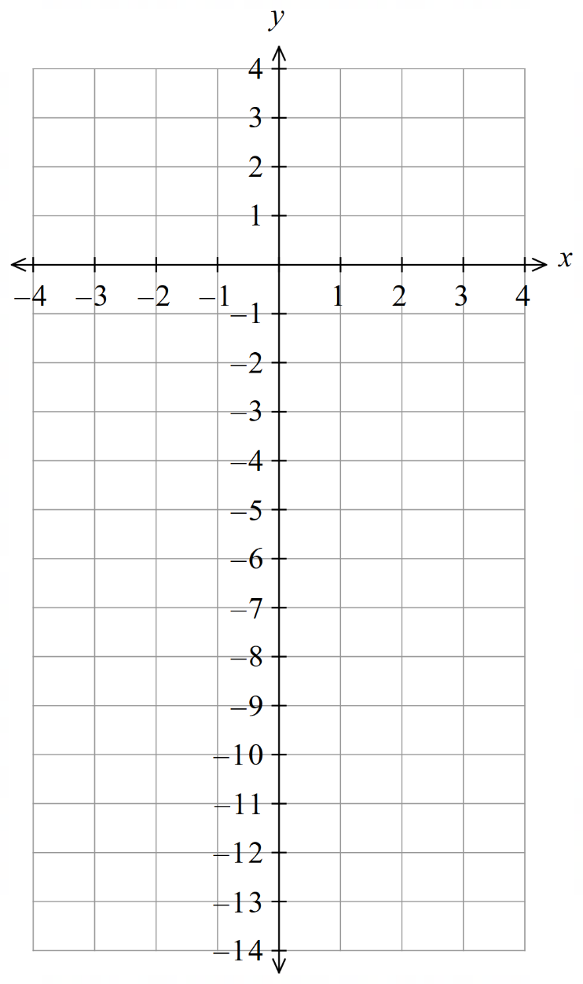
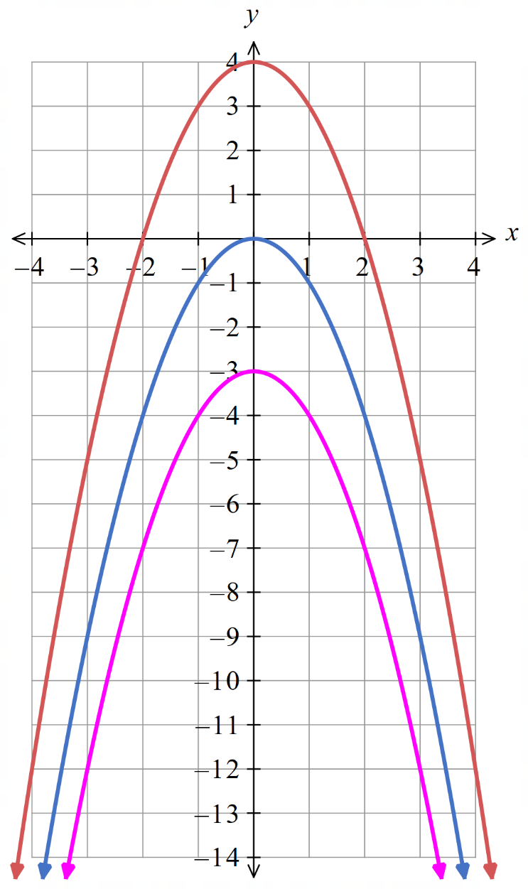
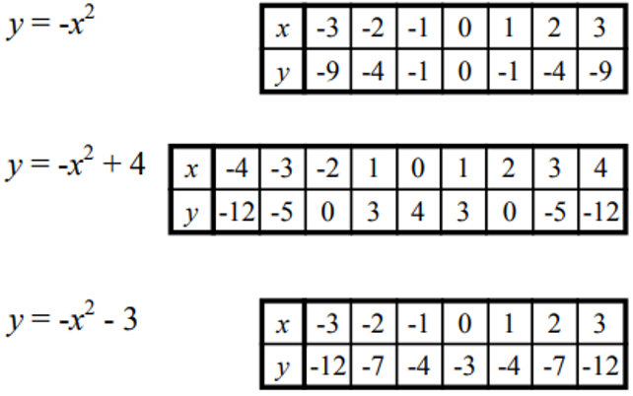

Circle the correct option:
The constant term affects the parabola by:
- Shifting the parabola up or down.
- Determining where the parabola cuts the $y$-axis.
- Both of the above.

C
- Which of the cards show the equation of a straight line and
which show the equation of a parabola?
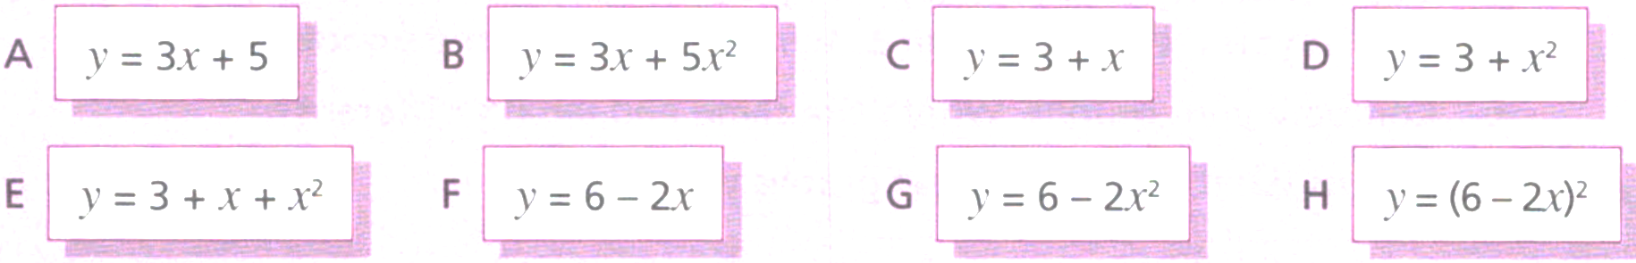

Straight line: A, C, F
Parabola: B, D, E, G, H
- “When you square a negative number you get a positive number, so the graph of $y=-x^{2}$ is the same as $y=x^{2}$”
Explain why this statement is incorrect.
………………………………………………………………………………………………………………
………………………………………………………………………………………………………………

$y=x^{2}$ is the same as $y={\left(-x\right)}^{2}$, but not $y=-x^{2}$
The negative sign is not in brackets, so it doesn’t get squared.

Properties of the Parabola

- Parabolas
A quadratic relationship $y=ax^{2}+bx+c$ produces a parabola-shaped graph.
Parabolas have these features:
- Line symmetry: Folding the parabola along this line makes both halves match.
- Vertex, or turning point: where the gradient changes direction.
The vertex is always on the axis of symmetry.
- The nature of the turning point (maximum or minimum) depends on coefficient of $x^{2}$
- The maximum or minimum value is the $y$ value at the turning point.

$$a>0$$  Concave up | $$a<0$$  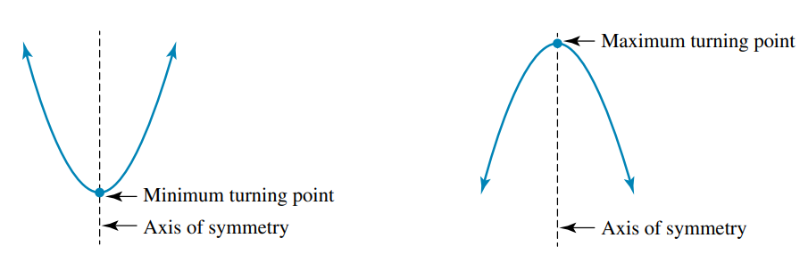  Concave down

- Identify key features of a parabola
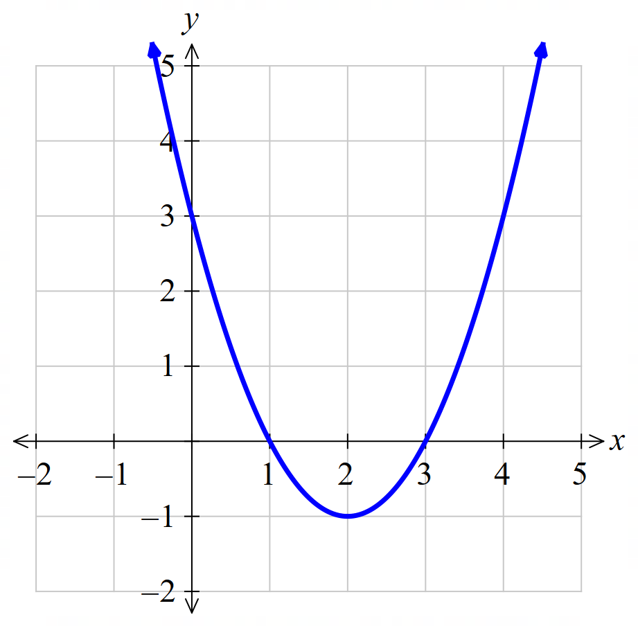  Turning point and nature:  Axis of symmetry:  $y$-intercept:  $x$-intercept:  Minimum value: | 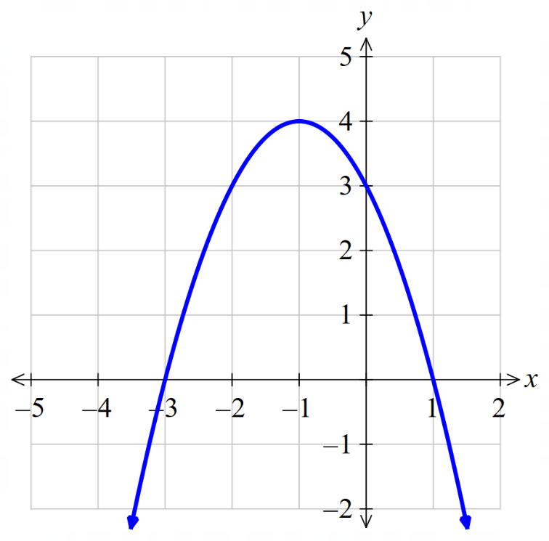  Turning point and nature:  Axis of symmetry:  $y$-intercept:  $x$-intercept:  Maximum value:

Foundation
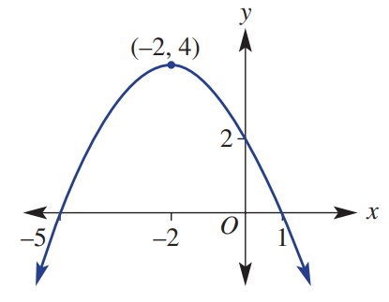
- Complete the sentences.
  - The parabola has a …………………… turning point.
maximum
  - The coordinates of the turning point are ………………
$$(-2,4)$$
  - The y-intercept is ………………
$$(0,2)$$
  - The x -intercepts are ………………and ………………
$(-5,0)$ $\left(1,0\right)$
  - The axis of symmetry is ………………
$$x=-2$$
- Determine the key features of these parabolas.
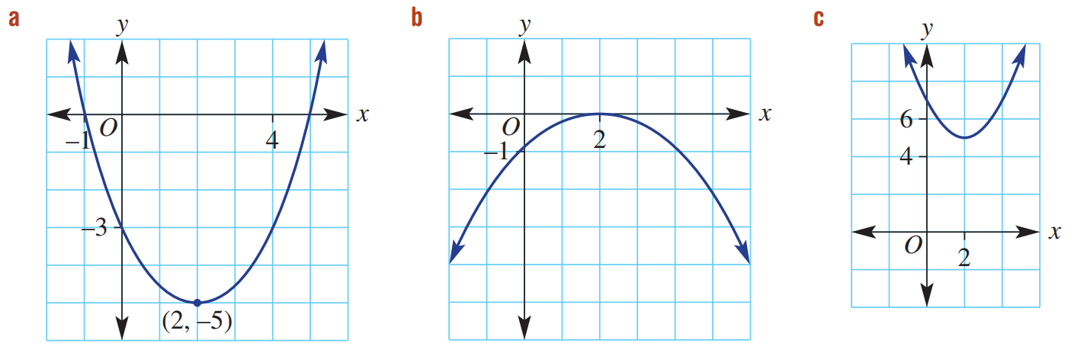  Vertex:  $$\left(2,-5\right)$$  Nature of turning point:  minimum  Axis of symmetry:  $$x=2$$  $x$ intercepts:  $\left(-1,0\right)$ $\left(5,0\right)$  $y$ intercept:  $$\left(0,-3\right)$$ | Vertex:  $$\left(2,0\right)$$  Nature of turning point:  maximum  Axis of symmetry:  $$x=2$$  $x$ intercepts:  $$\left(2,0\right)$$  $y$ intercept:  $$\left(0,-1\right)$$ | Vertex:  $$\left(2,5\right)$$  Nature of turning point:  minimum  Axis of symmetry:  $$x=2$$  $x$ intercepts:  none  $y$ intercept:  $$\left(0,7\right)$$
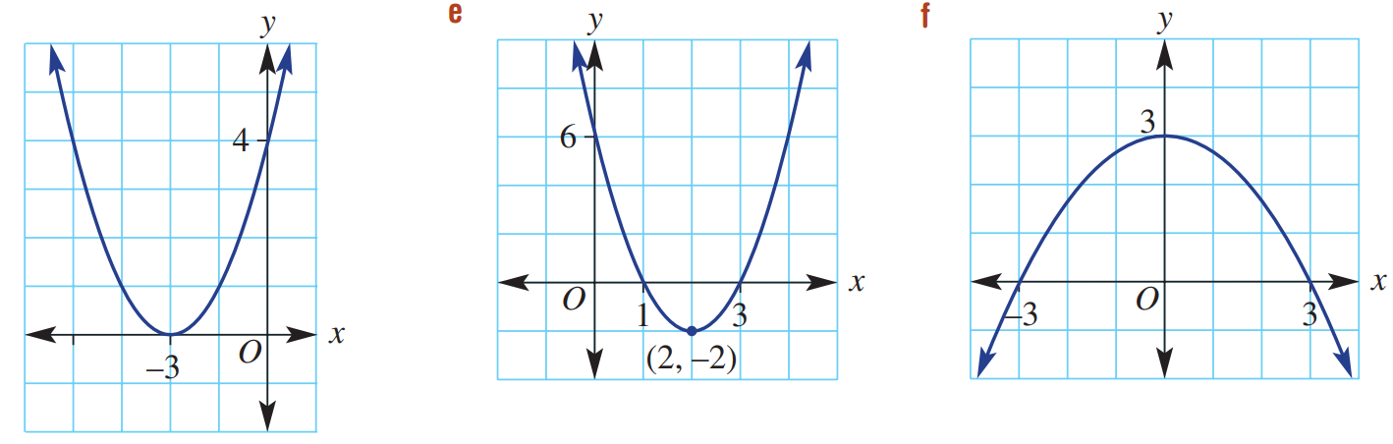  Vertex:  $$\left(-3,0\right)$$  Nature of turning point:  minimum  Axis of symmetry:  $$x=-3$$  $x$ intercepts:  $$\left(-3,0\right)$$  $y$ intercept:  $$\left(0,4\right)$$ | Vertex:  $$\left(2,-2\right)$$  Nature of turning point:  minimum  Axis of symmetry:  $$x=2$$  $x$ intercepts:  $$\left(1,0\right) \left(3,0\right)$$  $y$ intercept:  $$\left(0,6\right)$$ | Vertex:  $$(0,3)$$  Nature of turning point:  maximum  Axis of symmetry:  $$x=0$$  $x$ intercepts:  $$\left(-3,0\right) \left(3,0\right)$$  $y$ intercept:  $$\left(0,3\right)$$

Development
- Determine the key features of these parabolas.
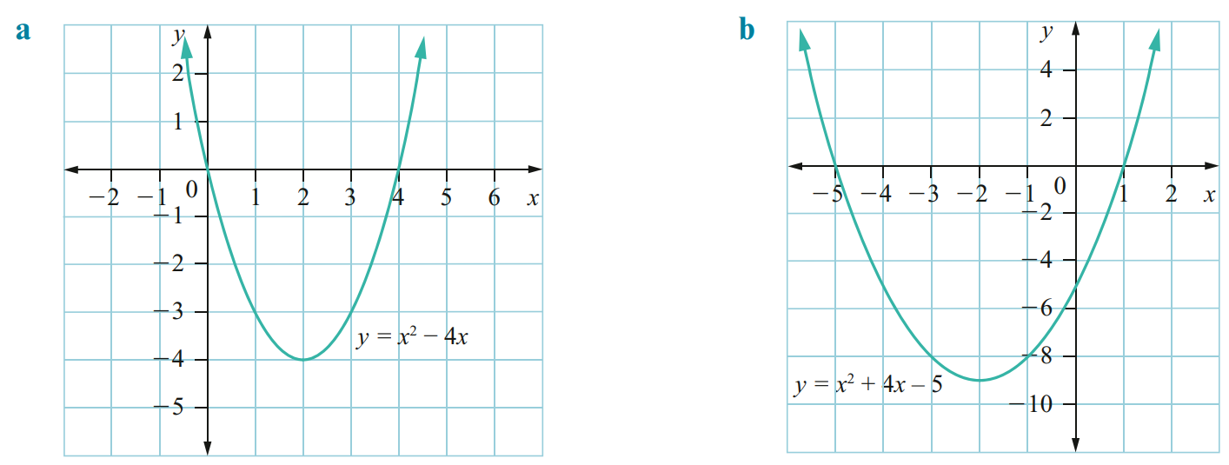  Vertex:  $$\left(2,-4\right)$$  Nature of turning point:  minimum  Axis of symmetry:  $$x=2$$  $y$-intercept:  $$\left(0,-4\right)$$  $x$-intercepts:  $$\left(0,0\right) \left(4,0\right)$$  Maximum/minimum value:  Min at $y=-4$ | Vertex:  $$\left(-2,-9\right)$$  Nature of turning point:  minimum  Axis of symmetry:  $$x=-2$$  $y$-intercept:  $$\left(0,-5\right)$$  $x$-intercepts:  $$\left(-5,0\right) \left(1,0\right)$$  Maximum/minimum value:  Min at $y=-9$
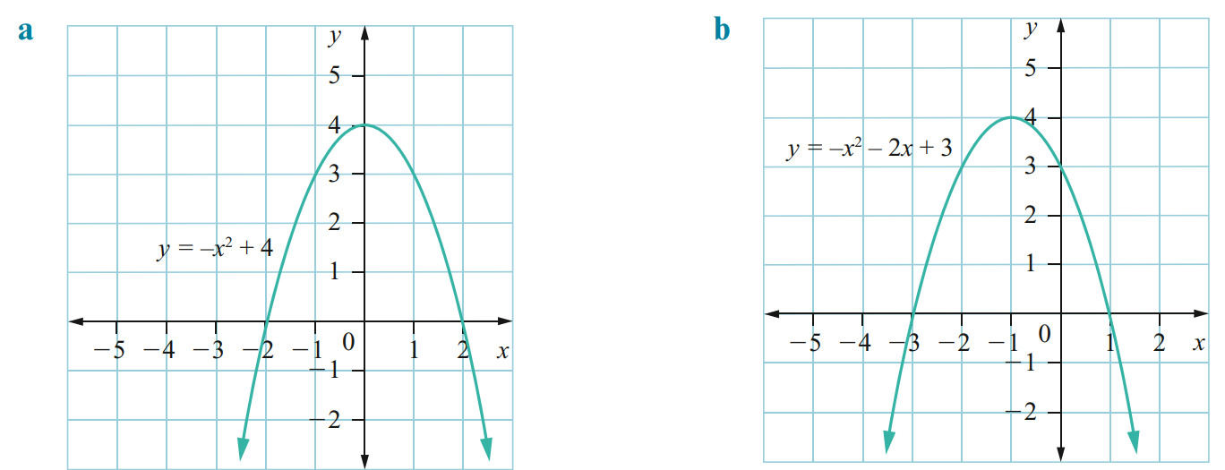  Vertex:  $$\left(0,4\right)$$  Nature of turning point:  maximum  Axis of symmetry:  $$x=0$$  $y$-intercept:  $$\left(0,4\right)$$  $x$-intercepts:  $$\left(-2,0\right) \left(2,0\right)$$  Maximum/minimum value:  Max at $y=4$ | Vertex:  $$\left(-1,4\right)$$  Nature of turning point:  maximum  Axis of symmetry:  $$x=-1$$  $y$-intercept:  $$\left(0,3\right)$$  $x$-intercepts:  $$\left(-3,0\right) \left(1,0\right)$$  Maximum/minimum value:  Max at $y=4$

- Sketch these parabolas from their equation.
- $y=-x^{2}+6x-5$  Vertex:  $$\left(3,4\right)$$  Nature of turning point:  maximum  Axis of symmetry:  $$x=3$$  $y$-intercept:  $$\left(0,-5\right)$$  $x$-intercepts:  $$\left(1,0\right) \left(5,0\right)$$  Maximum/minimum value:  Max at $y=4$ | - $y=2x^{2}-4x-6$  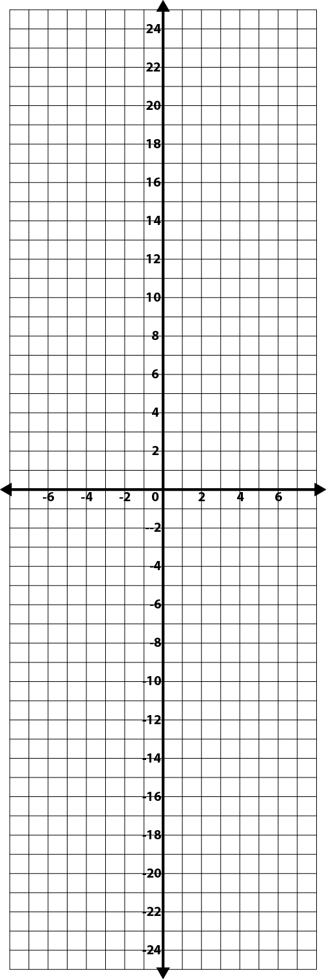  Vertex:  $$\left(1,-8\right)$$  Nature of turning point:  minimum  Axis of symmetry:  $$x=1$$  $y$-intercept:  $$\left(0,-6\right)$$  $x$-intercepts:  $$\left(-1,0\right) \left(3,0\right)$$  Maximum/minimum value:  Min at $y=-8$
  $$x$$ | $$-1$$ | $$0$$ | $$1$$ | $$2$$ | $$3$$ | $$4$$ | $$5$$
  $$y$$
  $$x$$ | $$-2$$ | $$-1$$ | $$0$$ | $$1$$ | $$2$$ | $$3$$ | $$4$$
  $$y$$
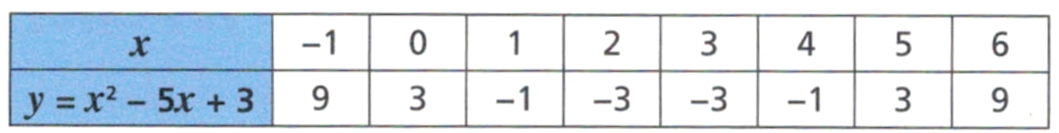
- Rhys is drawing the graph
of $y=x^{2}-5x+3$
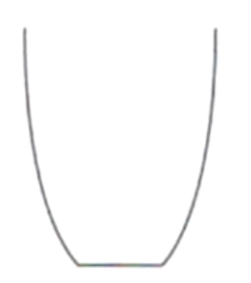
He notices that the $x$-values 2 and 3 have the same $y$-value and thinks that the graph will look like this.
Rhys is wrong.
At what value of $x$ will the lowest point of the graph be? How do you know?

2.5, as it is the midpoint of 2 and 3
What will the $y$-value be at this point?

$$y={\left(2.5\right)}^{2}-5\left(2.5\right)+3=-3.25$$

Basic Transformations of the Parabola

- Investigation Equation and graph of the parabola
- https://www.desmos.com/calculator

- Sketch these graphs  $y=x^{2}$  $y=2x^{2}$  $y=3x^{2}$  $y=4x^{2}$  Increasing the ………………… of $x^{2}$ makes the graph ……………… | - Sketch these graphs.  $y=x^{2}$  $y=\frac{1}{2}x^{2}$  $y=\frac{1}{3}x^{2}$  $y=\frac{1}{4}x^{2}$  Decreasing the …………… of $x^{2}$ makes the graph …………………
- Sketch these graphs.  $y=x^{2}$  $y=-x^{2}$  $y=-$ $\frac{1}{2}$ $x^{2}$  $y=-2x^{2}$  A ……………… coefficient of $x^{2}$ makes the graph concave …………… | - Sketch these graphs.  $y=x^{2}$  $y=x^{2}+1$  $y=x^{2}+2$  $y=x^{2}+3$  $y=x^{2}-1$  $y=x^{2}-2$  The c…………… t…………… shifts the parabola v…………………

- Basic Parabola Transformations
- https://www.desmos.com/calculator/m4rrcqccef
For a parabola $y=ax^{2}+c$
The variables $a,k$ are numbers that affect the graph in predictable ways.
These special variables are called parameters.
$c>0$, the parabola is shifted ……………  $$y=x^{2}+3$$  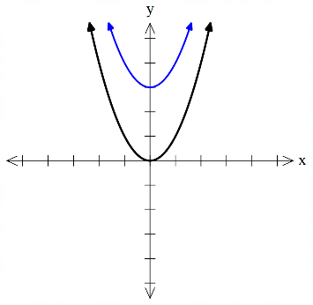 | $c<0$, the parabola is shifted ……………  $$y=x^{2}-3$$  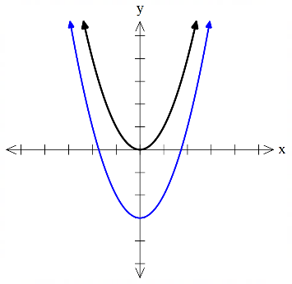
$a>0$, the parabola is concave ……………,  with a ………………… turning point.  $$y=1x^{2}$$  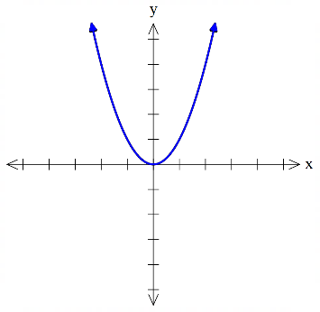 | $a<0$, the parabola is concave ……………,  with a ……………… turning point.  $$y=-1x^{2}$$  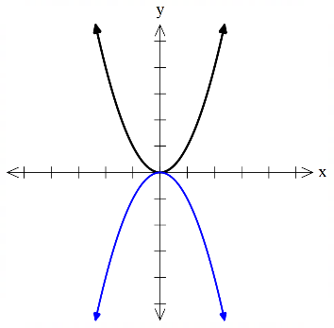
$\left|a\right|>1$, the parabola gets …………….  $$y=3x^{2}$$ | $0<\left|a\right|<1$ the parabola gets …………….  $$y=\frac{1}{3}x^{2}$$  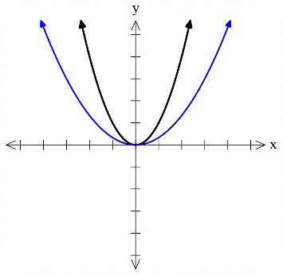  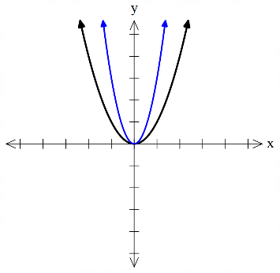

Foundation
- Choose the equation that matches each parabola.
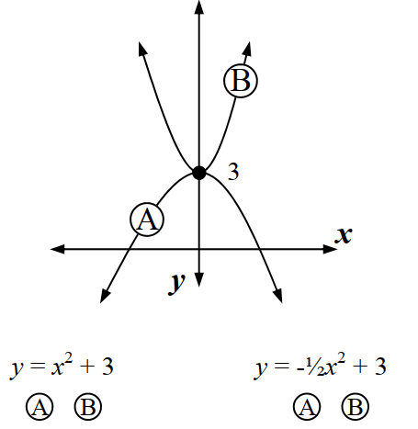  B A | 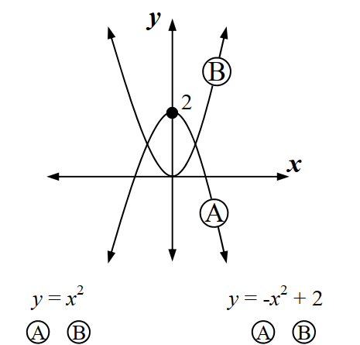  B A | 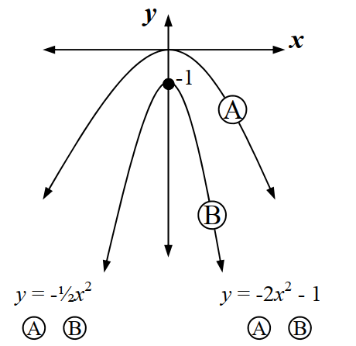  A B
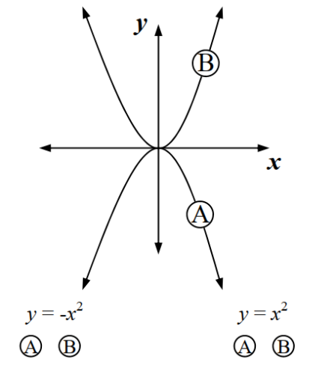  A B | 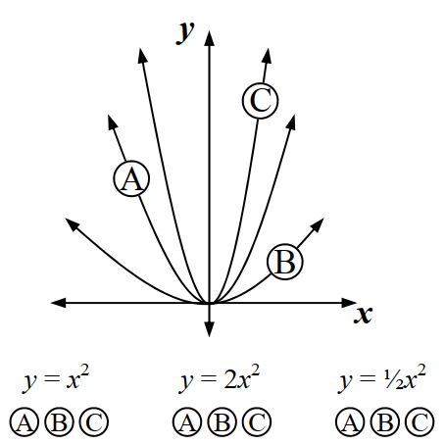  A C B | 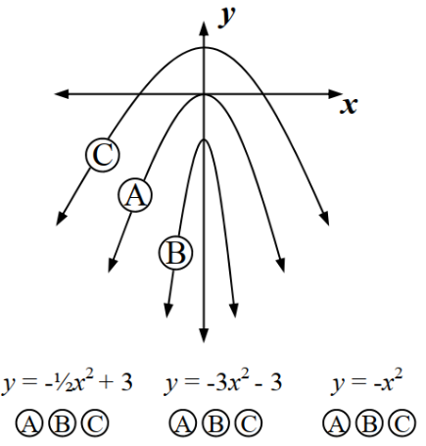  C B A

- Match each parabola to its equation.
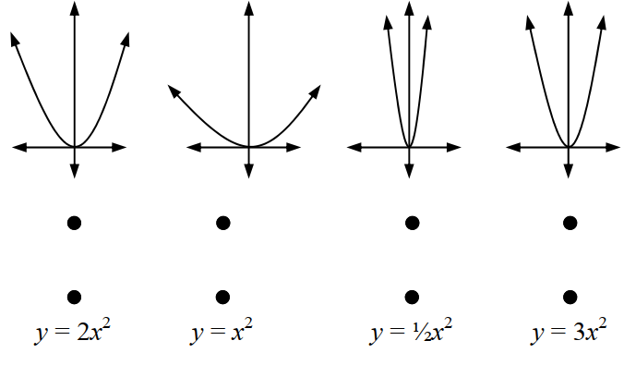  A B C D  D A B C | 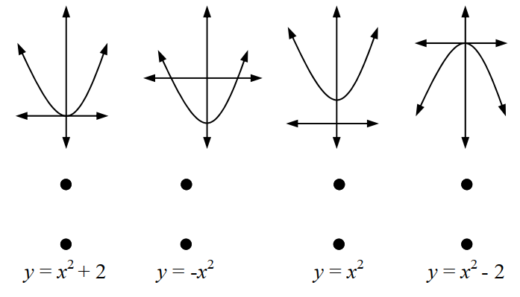  A B C D  C D A B
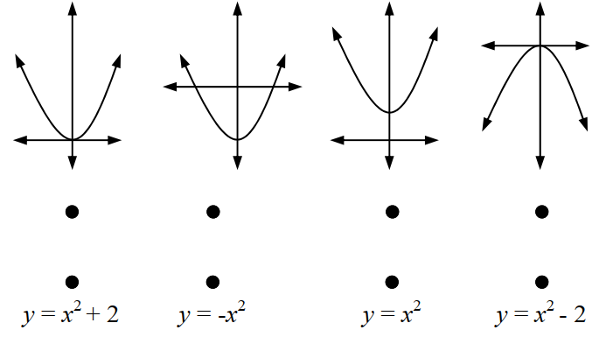  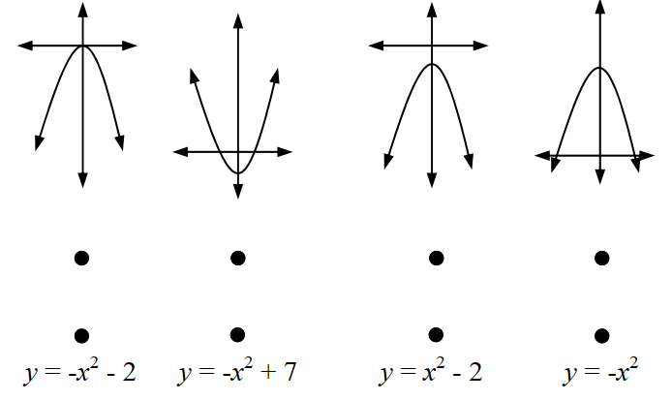  A B C D  C D B A | A B C D  C D A B

Development
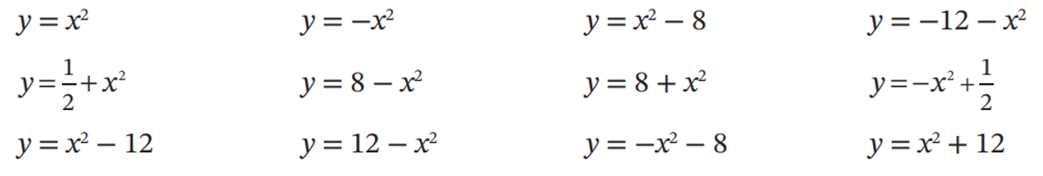
- Match these parabolas to their equation.
c g f l

j a k i

b e d h
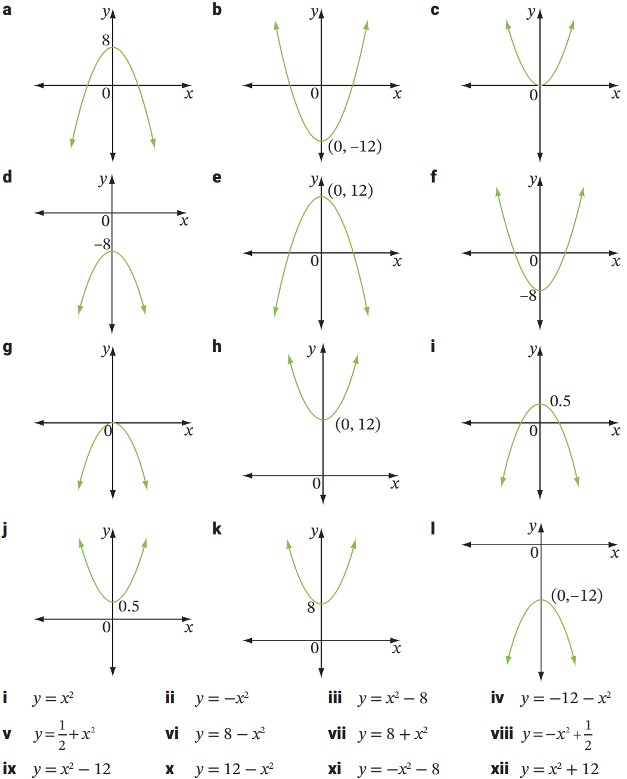

Exponential Relationships

- Exponential Relationships
Exponential relationships are in the form $y=a^{x}$.
Their graph will not be a straight line; the relationship is non-linear.
We can graph exponential relationships the same way as before:
- Construct a table of values using the equation.
- Graph the table by using the columns as coordinates.
- Join the points to form a smooth curve.
Consecutive $y$ values change by a common ratio, which is the base number $a$.

- Investigation Graph exponential relationships using a table of values
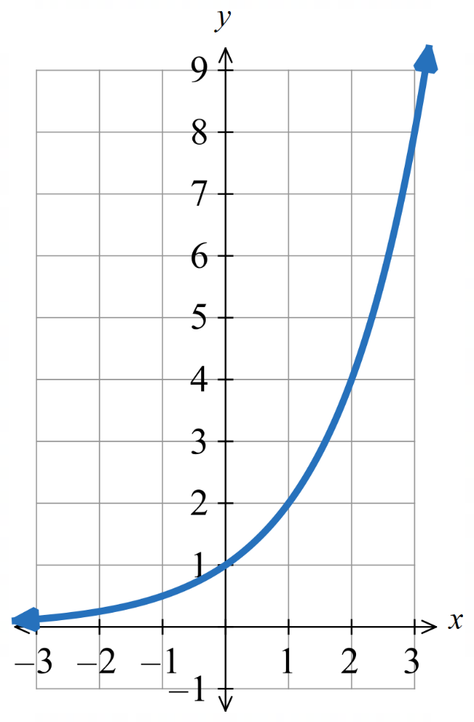
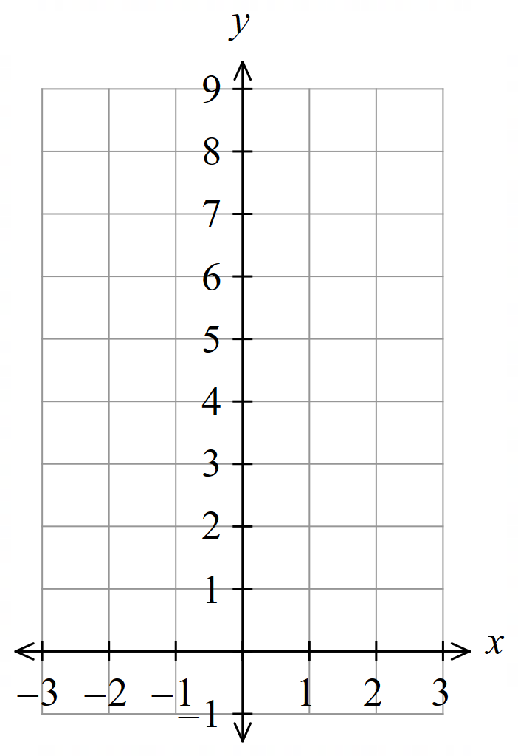
Draw the graph of $y=2^{x}$
$$x$$ | $$-3$$ | $$-2$$ | $$-1$$ | $$0$$ | $$1$$ | $$2$$ | $$3$$
$$y$$

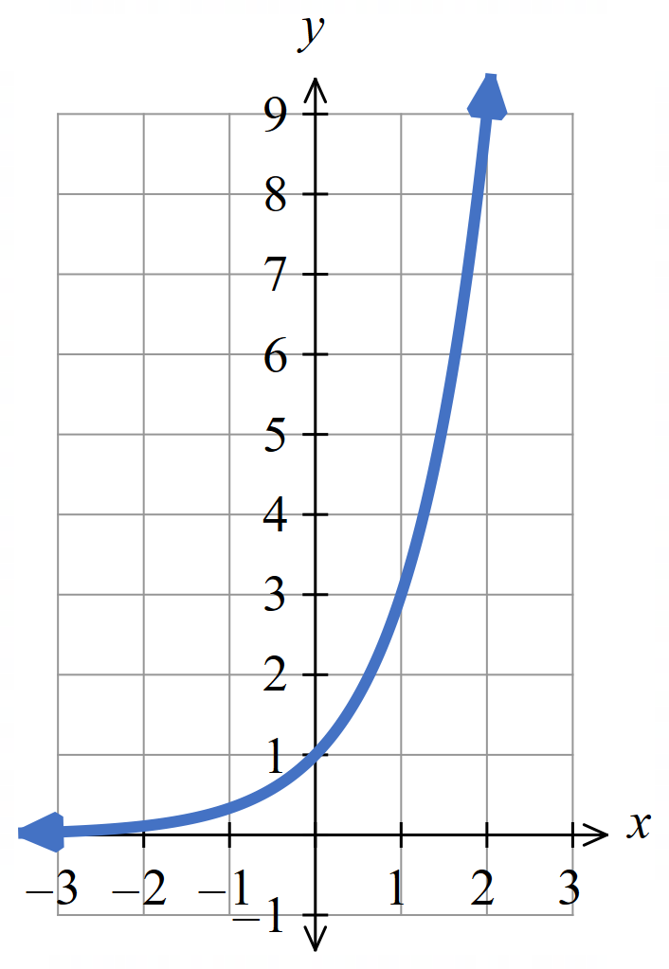
Draw the graph of $y=3^{x}$

$$x$$ | $$-3$$ | $$-2$$ | $$-1$$ | $$0$$ | $$1$$ | $$2$$ | $$3$$
$$y$$

Foundation
- Sketch these exponential curves.
- $y=4^{x}$  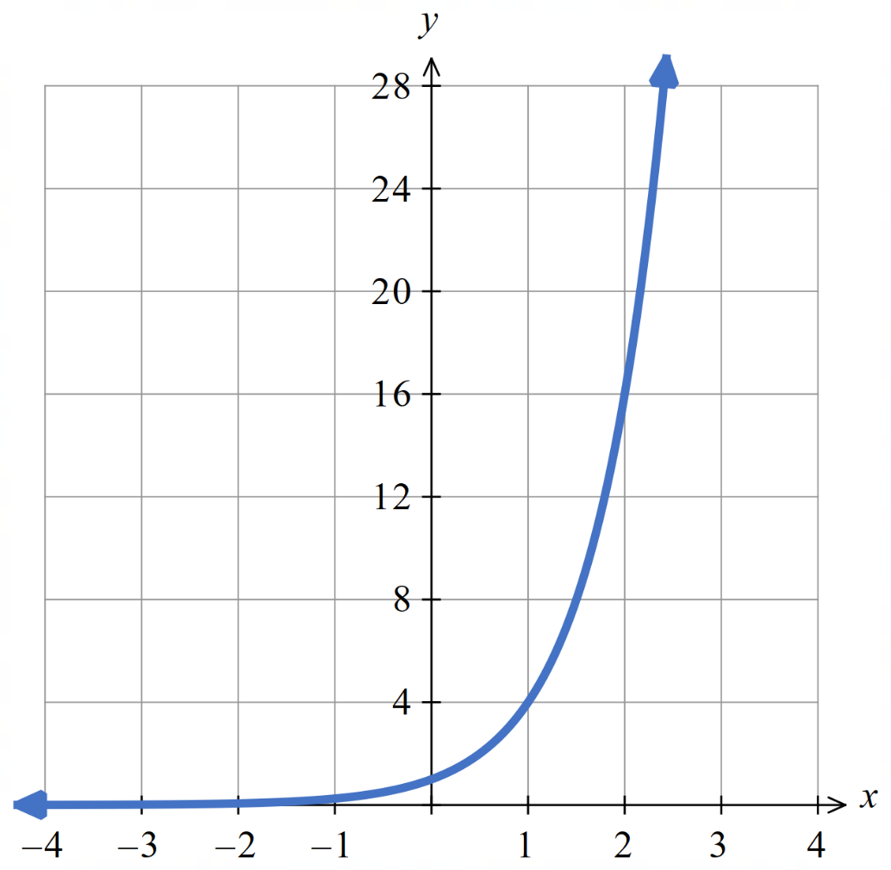  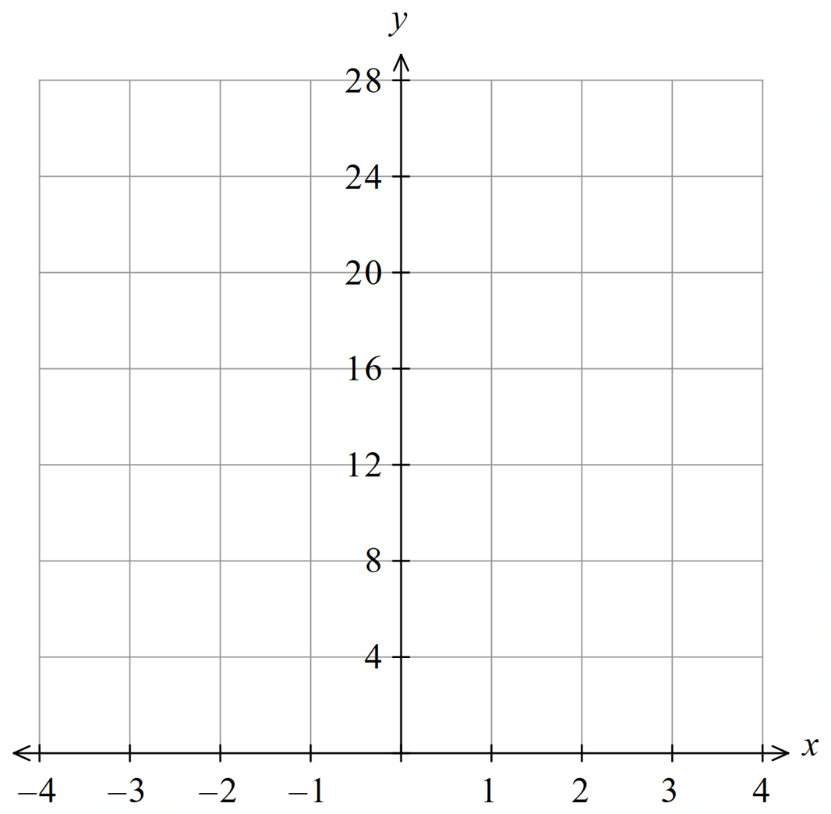 | - $y=2^{x}+4$  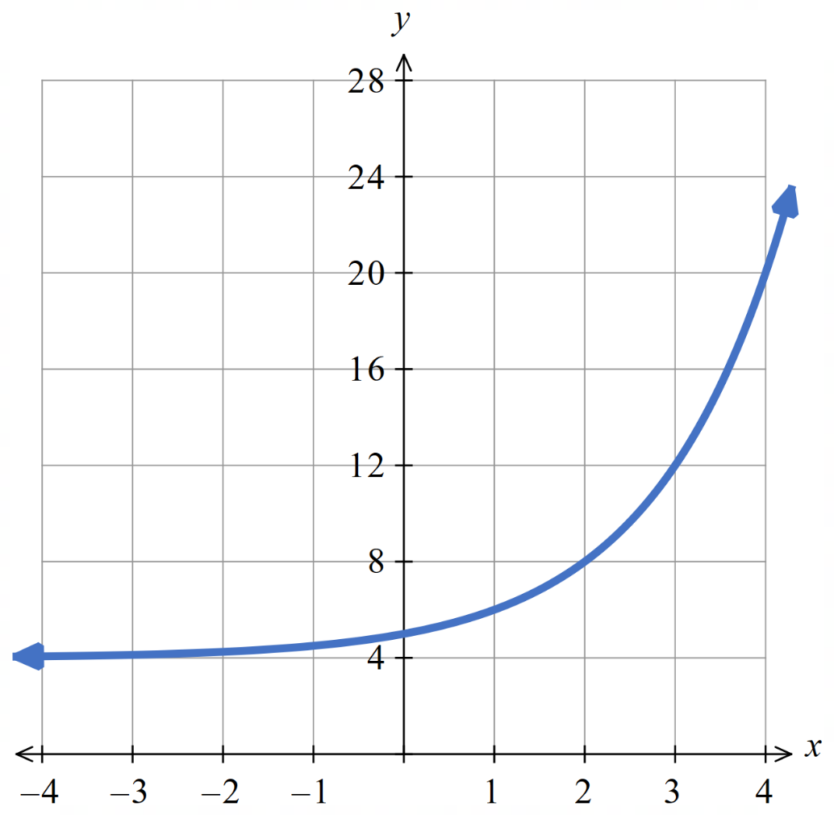
  $$x$$ | $$-3$$ | $$-2$$ | $$-1$$ | $$0$$ | $$1$$ | $$2$$ | $$3$$
  $$y$$
  $$x$$ | $$-3$$ | $$-2$$ | $$-1$$ | $$0$$ | $$1$$ | $$2$$ | $$3$$
  $$y$$
- $y=-2^{x}$  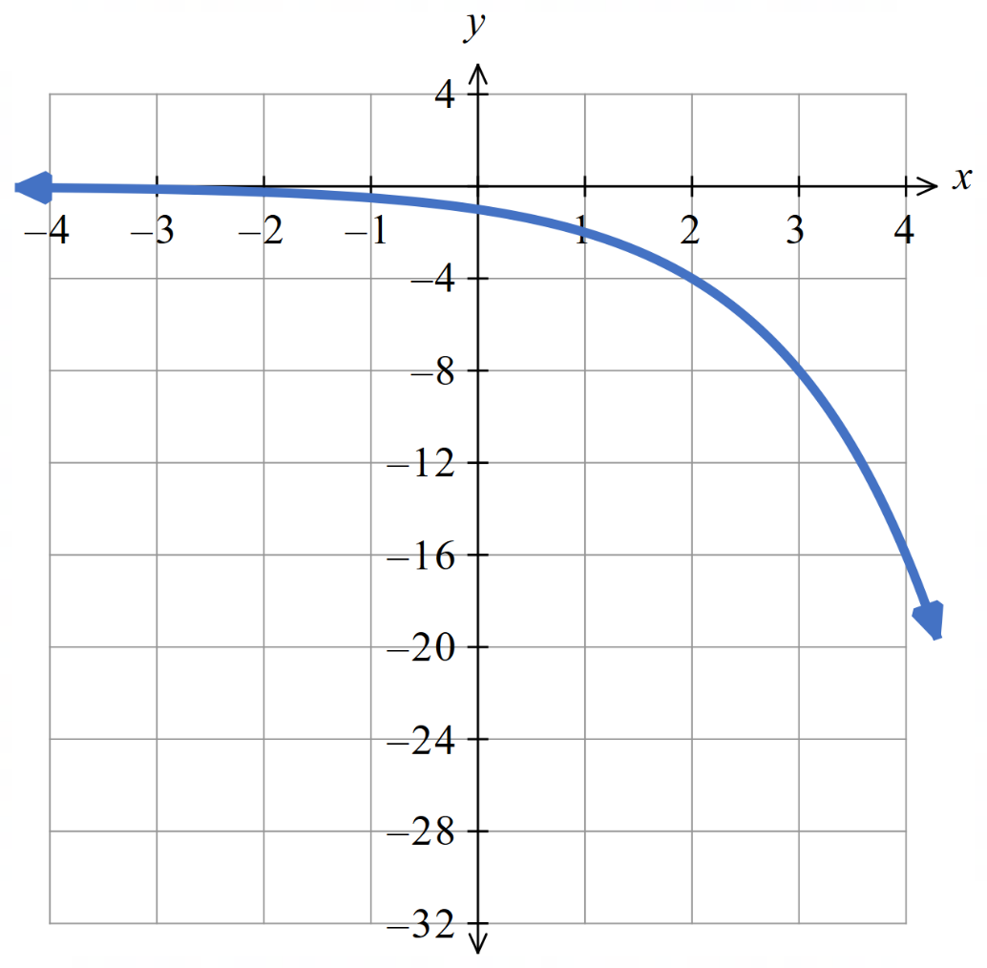  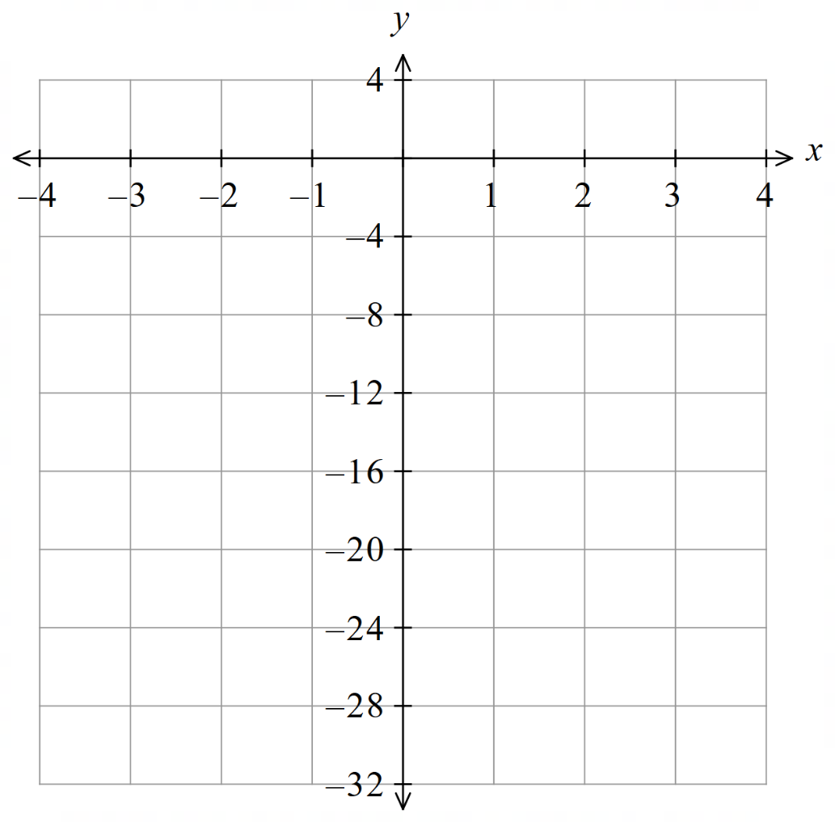 | - $y=-3^{x}$  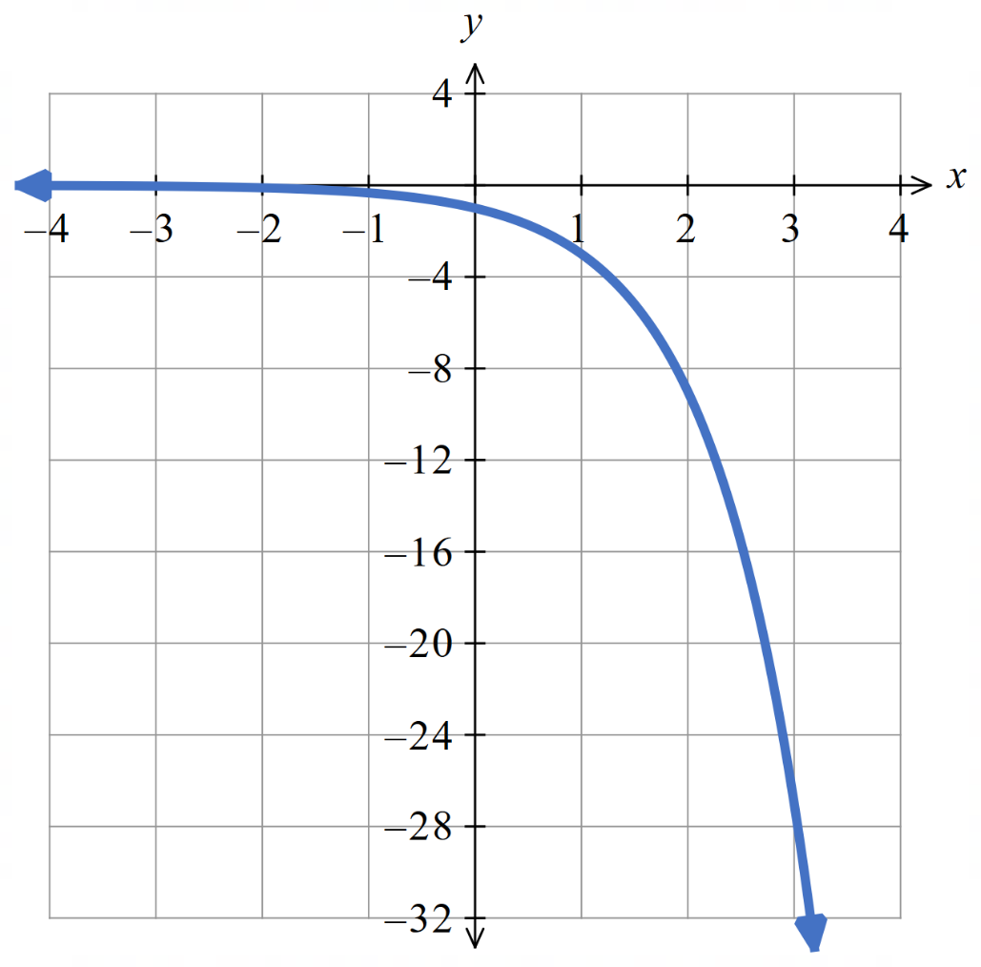
  $$x$$ | $$-3$$ | $$-2$$ | $$-1$$ | $$0$$ | $$1$$ | $$2$$ | $$3$$
  $$y$$
  $$x$$ | $$-3$$ | $$-2$$ | $$-1$$ | $$0$$ | $$1$$ | $$2$$ | $$3$$
  $$y$$

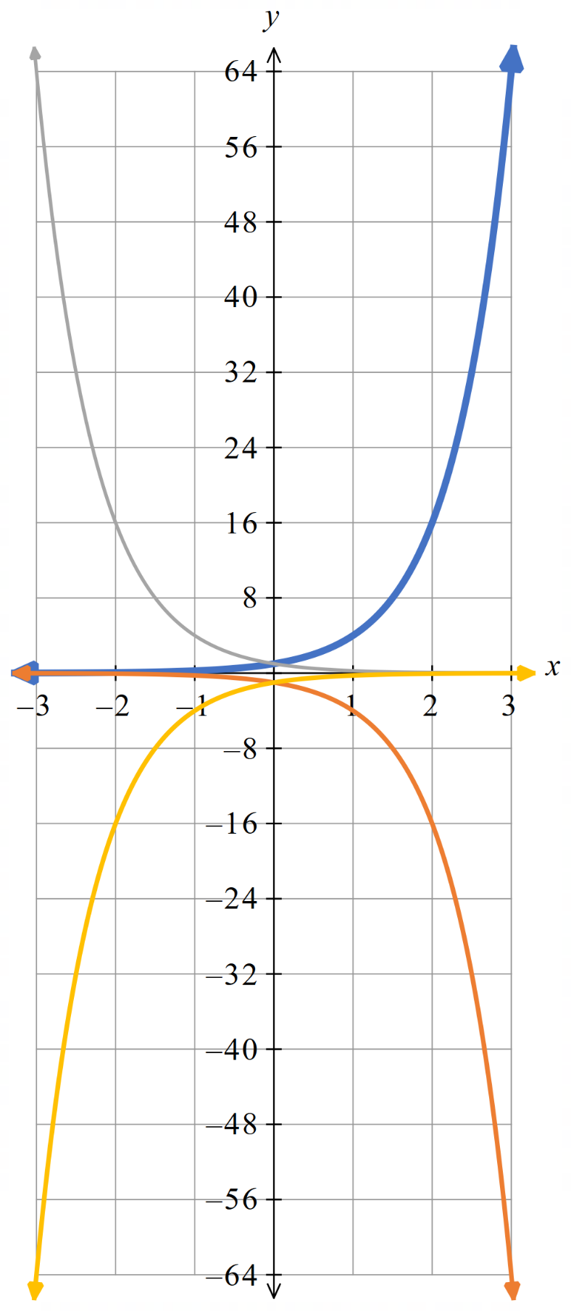
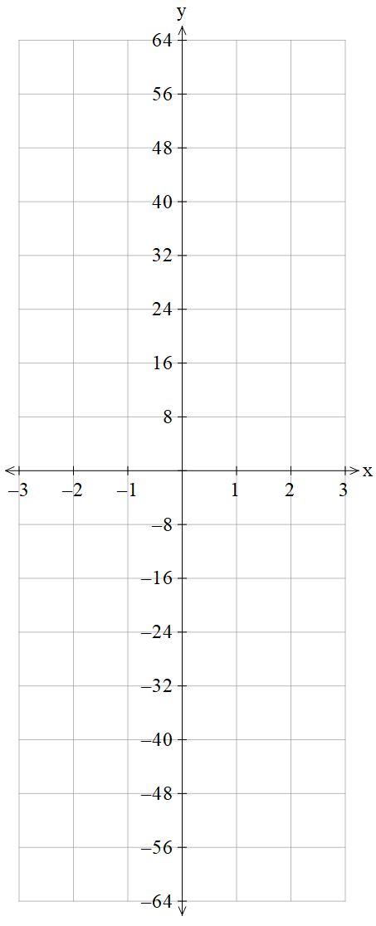
- Sketch these exponential curves on the same axis.
  - $y=4^{x}$
$$x$$ | $$-3$$ | $$-2$$ | $$-1$$ | $$0$$ | $$1$$ | $$2$$ | $$3$$
$$y$$

  - $y=-4^{x}$
$$x$$ | $$-3$$ | $$-2$$ | $$-1$$ | $$0$$ | $$1$$ | $$2$$ | $$3$$
$$y$$

  - $y=4^{-x}$
$$x$$ | $$-3$$ | $$-2$$ | $$-1$$ | $$0$$ | $$1$$ | $$2$$ | $$3$$
$$y$$

  - $y=-4^{-x}$
$$x$$ | $$-3$$ | $$-2$$ | $$-1$$ | $$0$$ | $$1$$ | $$2$$ | $$3$$
$$y$$

What do you notice?

The graphs are reflections of each other across an axis.

Properties of the Exponential Curve

- Exponential Curves
An exponential relationship $y=a^{x}$ produces exponential curve graphs.
Exponential curves have these features:
- An asymptote: a line the graph approaches but never reaches.
- The nature of the graph (growth or decay) depends on the sign of $x$.
- Consecutive $y$ values change by a common ratio, which is the base number $a$.
$$y=a^{x}, a>1$$  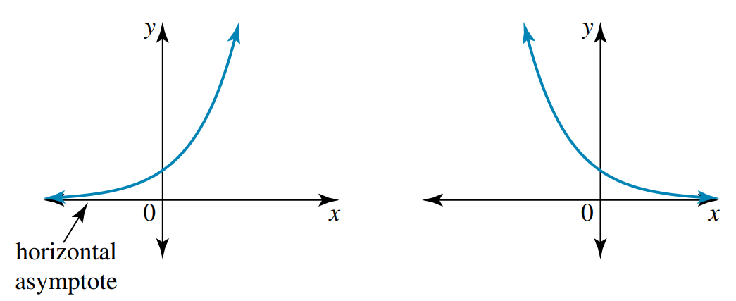  Increasing, exponential growth | $$y=a^{-x}, a>1$$  Decreasing, exponential decay

- Identify key features of an exponential curve
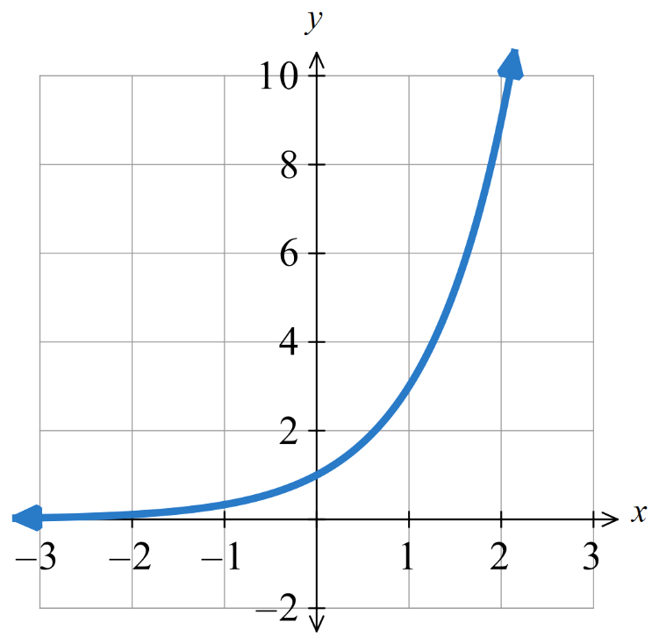  $y-$ intercept:  Asymptote:  Nature:  What happens to $y$ when $x→∞?$  What happens to $y$ when $x→-∞?$ | 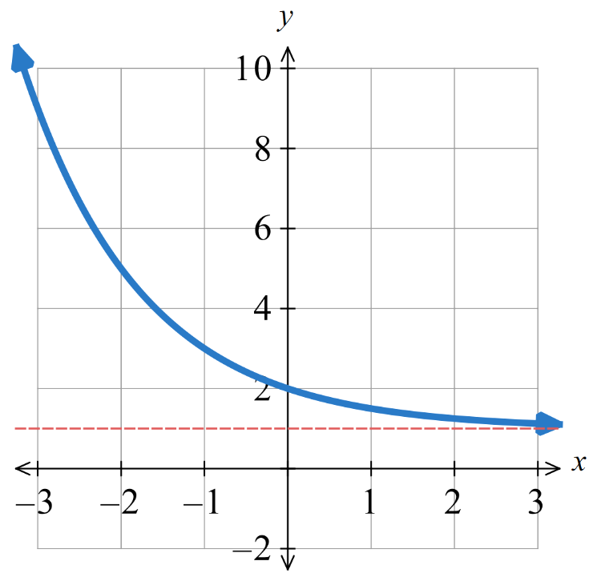  $y-$ intercept:  Asymptote:  Nature:  What happens to $y$ when $x→∞?$  What happens to $y$ when $x→-∞?$

Foundation
- Consider these exponential curves.
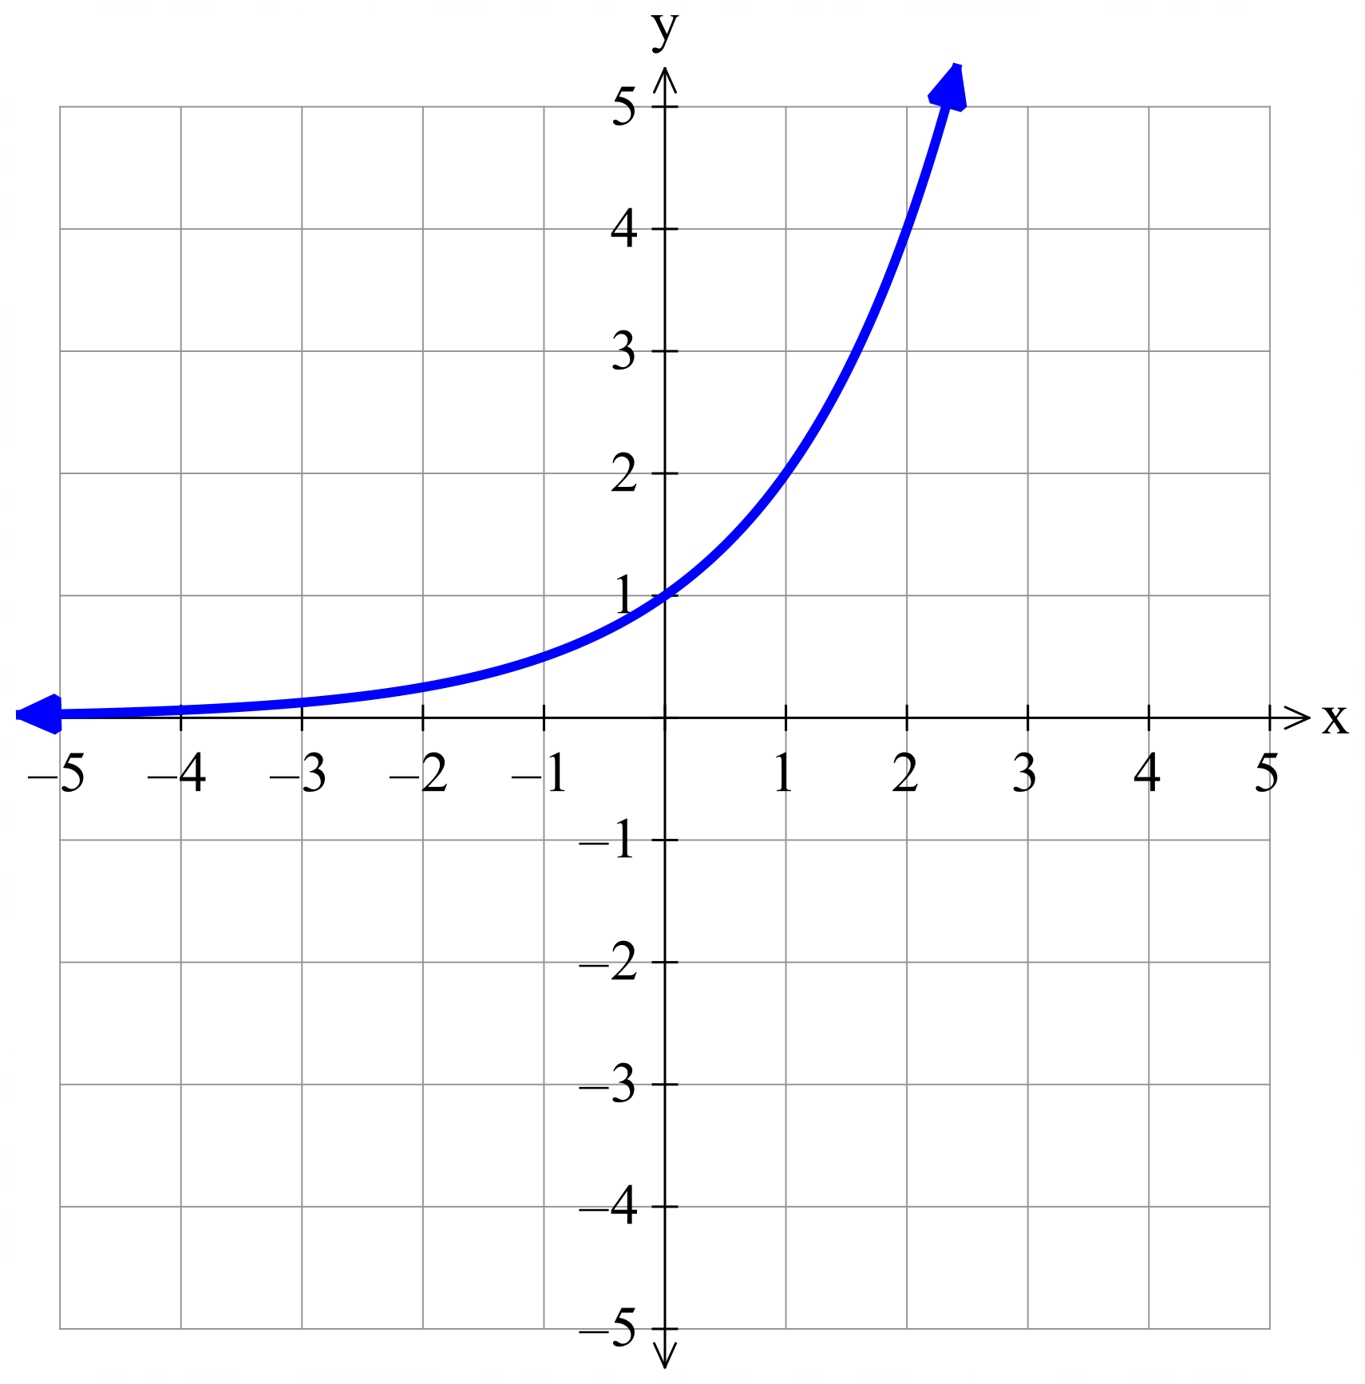  - $y=2^{x}$  $y$-intercept:  $$\left(0,1\right)$$  Asymptote:  $$y=0$$  Nature:  Increasing; exponential growth  What happens when $x→∞?$  $$y→∞$$  What happens when $x→-∞?$  $$y→0$$ | 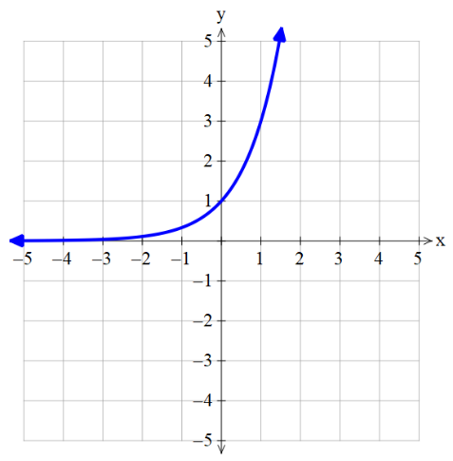  - $y=3^{x}$  $y$-intercept:  $$\left(0,1\right)$$  Asymptote:  $$y=0$$  Nature:  Increasing; exponential growth  What happens when $x→∞?$  $$y→∞$$  What happens when $x→-∞?$  $$y→0$$
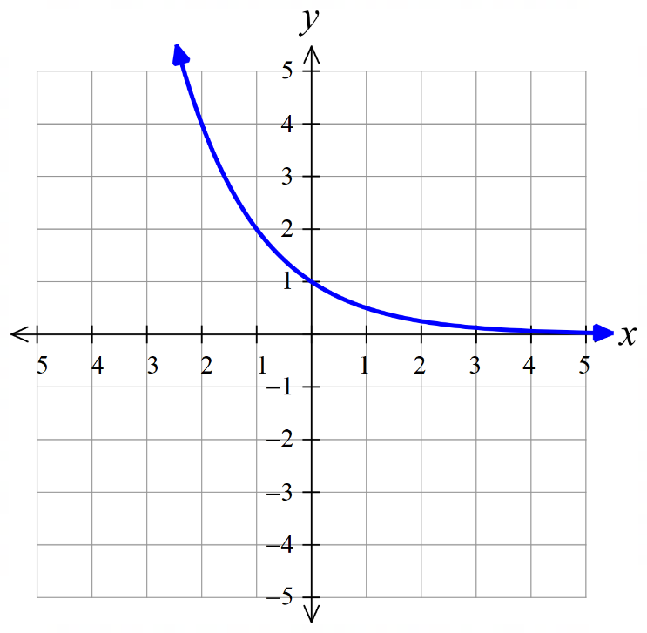  - $y={\left(\frac{1}{2}\right)}^{x}$  $y$-intercept:  $$\left(0,1\right)$$  Asymptote:  $$y=0$$  Nature:  decreasing; exponential decay  What happens when $x→∞?$  $$y→0$$  What happens when $x→-∞?$  $$y→∞$$ | - $y=2^{-x}$  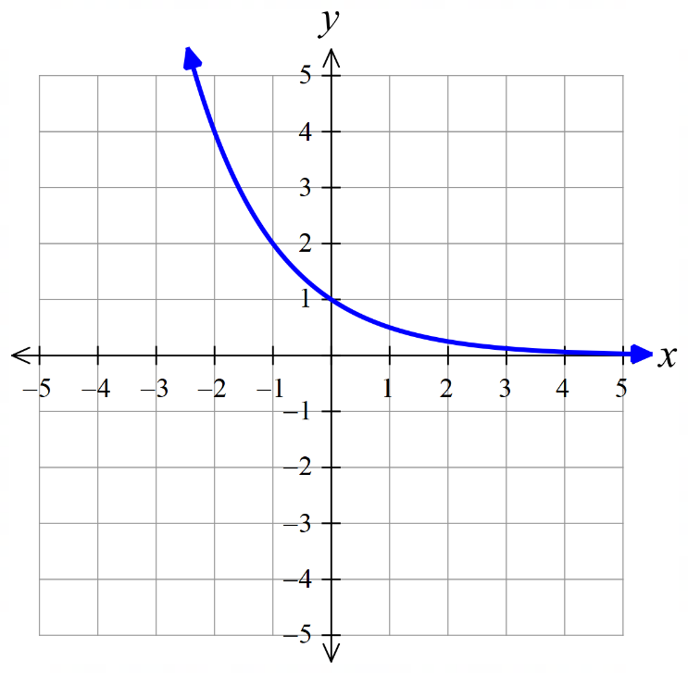  $y$-intercept:  $$\left(0,1\right)$$  Asymptote:  $$y=0$$  Nature:  decreasing; exponential decay  What happens when $x→∞?$  $$y→0$$  What happens when $x→-∞?$  $$y→∞$$

- What do you notice about part c and d above? Why?
They are the same.
This is due to the law of negative indices $y={\left(\frac{1}{a}\right)}^{x}=a^{-x}$
- Consider these exponential curves.
- $y=-2^{x}$  $y$-intercept:  $$\left(0,-1\right)$$  Asymptote:  $$y=0$$  What happens when $x→∞?$  $$y→-∞$$  What happens when $x→-∞?$  $$y→0$$ | 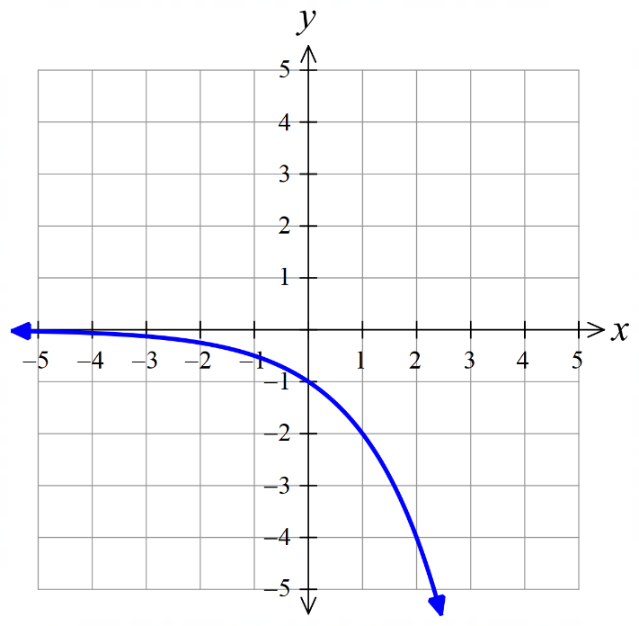  - $y=2^{x}+3$  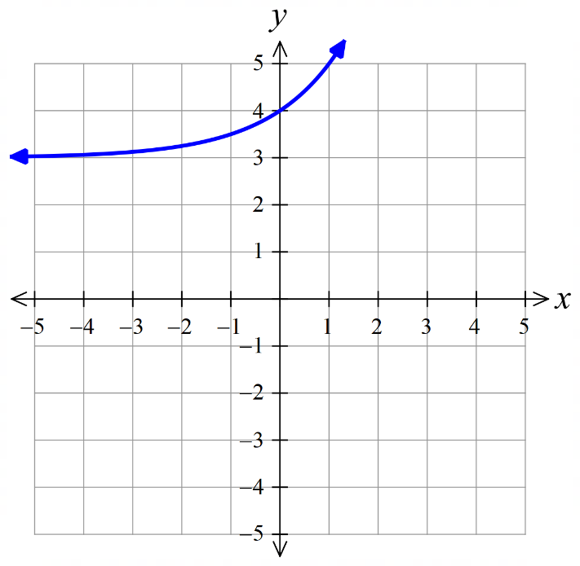  $y$-intercept:  $$\left(0,4\right)$$  Asymptote:  $$y=3$$  What happens when $x→∞?$  $$y→∞$$  What happens when $x→-∞?$  $$y→3$$
- $y=-2^{x}+3$  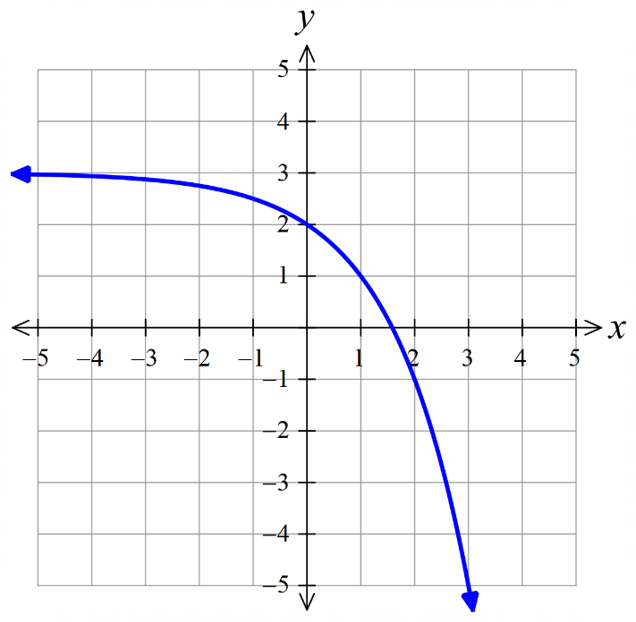  $y$-intercept:  $$\left(0,2\right)$$  Asymptote:  $$y=3$$  What happens when $x→∞?$  $$y→-∞$$  What happens when $x→-∞?$  $$y→3$$ | - $y={\left(\frac{1}{3}\right)}^{x}-2$  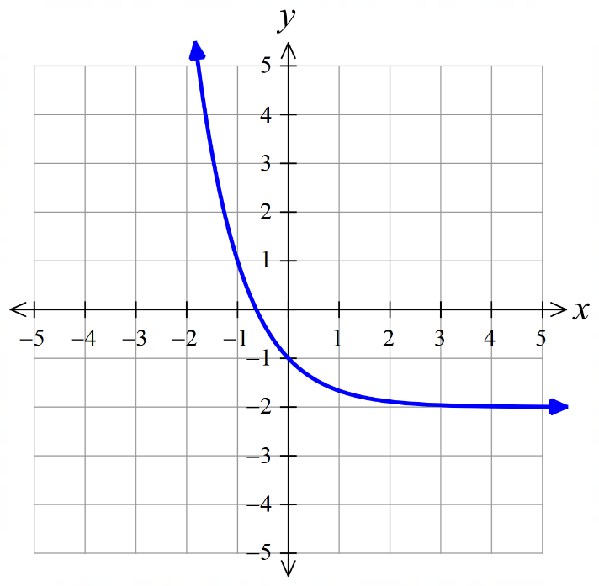  $y$-intercept:  $$\left(0,-1\right)$$  Asymptote:  $$y=-2$$  What happens when $x→∞?$  $$y→-2$$  What happens when $x→-∞?$  $$y→∞$$

Basic Transformations of the Exponential Curve

- Investigation Equation and graph of the exponential curve
- https://www.desmos.com/calculator

- Sketch these graphs  $y=2^{x}$  $y=3^{x}$  $y=4^{x}$  $$y=5^{x}$$  Increasing the base value makes the curve s……………………… | - Sketch these graphs.  $y=2^{x}$  $y={0.8}^{x}$  $$y={\left(\frac{1}{2}\right)}^{x}$$  $$y={\left(\frac{1}{3}\right)}^{x}$$  A base between $0$ and $1$ makes the graph e……………………… d………………
$y=2^{x}$  $y={-2}^{x}$  $$y={\left(\frac{1}{2}\right)}^{x}$$  $$y={-\left(\frac{1}{2}\right)}^{x}$$  A negative coefficient r……………… the curve across the …… axis. | $y=2^{x}$  $y={2(2)}^{x}$  $y={3(2)}^{x}$  $$y={5(2)}^{x}$$  The factor in front of the exponential tells you the … - ……………………
$y=2^{-x}$
$y={\left(\frac{1}{2}\right)}^{x}$
$y=a^{-x}$ is the same as $y={\left(\frac{1}{a}\right)}^{x}$ because of the n………………… i……………… l…………

- Exponential Curve Transformations
$a>1$ exponential growth  $0<a<1$ exponential decay  Common ratio  $$y=k⋅a^{x}$$  Factor; affects $y$-intercept and reflects across $x$ axis if negative |  | $a>1$ exponential decay  $0<a<1$ exponential growth  Common ratio  $$y=k⋅a^{-x}$$
$$y=2^{x}$$ | $y=2^{-x}$ or $y={\left(\frac{1}{2}\right)}^{x}$  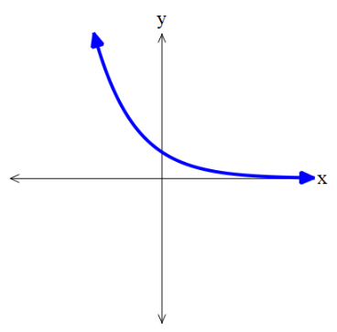 | $$y=-2^{x}$$  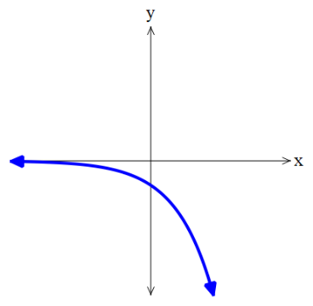  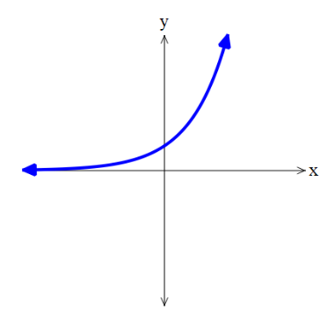 | $y=-2^{-x}$ or $y=-{\left(\frac{1}{2}\right)}^{x}$  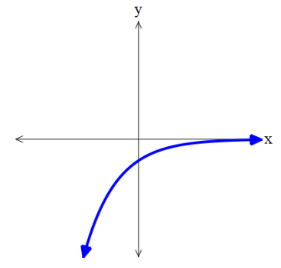

Foundation
- Plot $y=2^{x}$ and $y=3^{x}$ on the same axis.
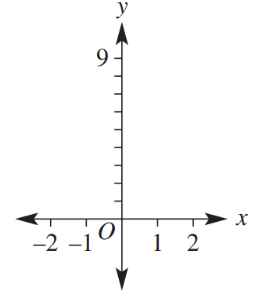
$y=2^{x}$
$$x$$ | $$-2$$ | $$-1$$ | $$0$$ | $$1$$ | $$2$$
$$y$$
$y=3^{x}$
$$x$$ | $$-2$$ | $$-1$$ | $$0$$ | $$1$$ | $$2$$
$$y$$

Describe their similarities and differences.
Similarities: ……………………………………………………………………………………………
Differences: ……………………………………………………………………………………………
Similar: both exponential growth, same $y$-intercept at $\left(0,1\right)$., same asymptote at $y=0$.
Different: $y=3^{x}$ increases faster.
- Match each equation to its graph. Check by substituting the given point into the equation.
A $y=-x-2$ | B $y=3^{x}$ | C $y=3^{-x}$
D $y=-2^{x}$ | E $y=x$ | F $y=-2^{-x}$

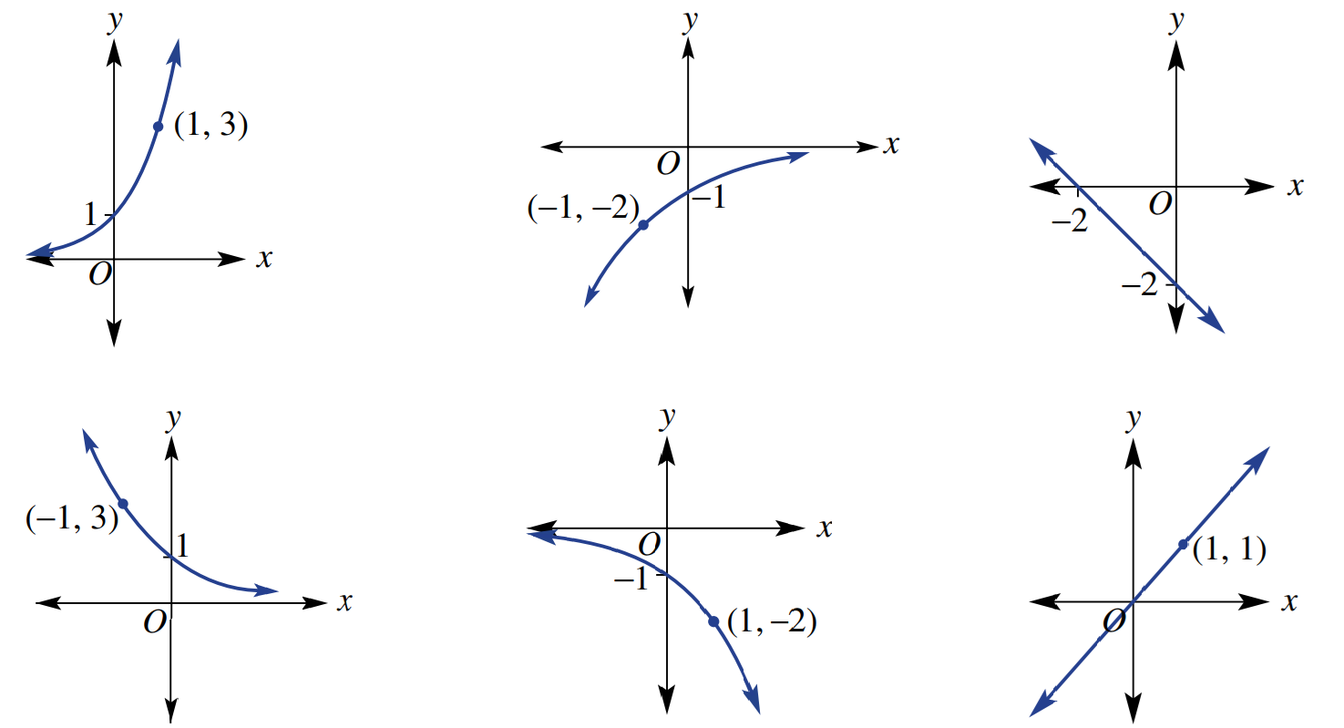

A – c, B – a, C – d, D – e, E – f, F - b

Development
- 2021 HSC Standard 2 Band 5
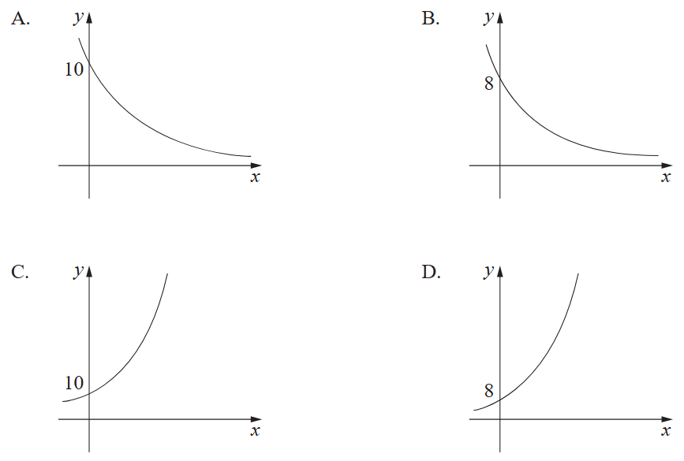
Which graph best represents the graph of $y=10{\left(0.8\right)}^{x}$?

A
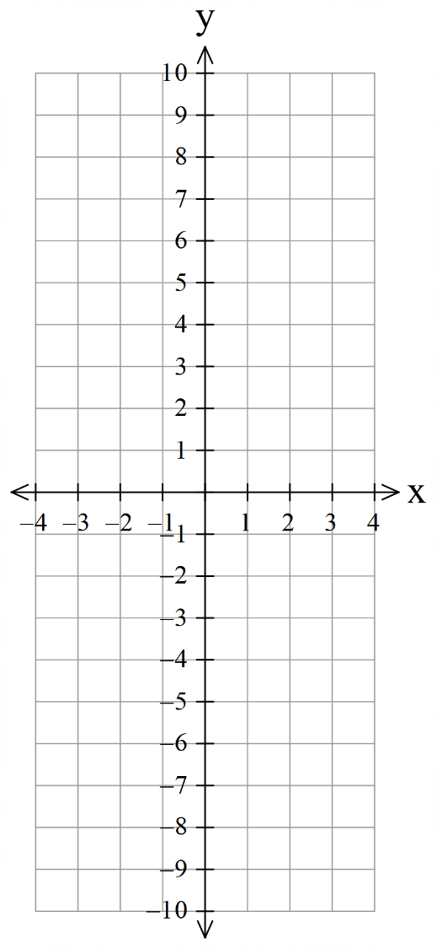
- Plot these graphs on the same axis.
$$x$$ | $$-3$$ | $$-2$$ | $$-1$$ | $$0$$ | $$1$$ | $$2$$ | $$3$$
$y=2^{x}$
$y={-2}^{x}$
$y=2^{-x}$

  - Show the difference between $2^{-2}$ and $-2^{2}$

$$2^{-2}=\frac{1}{4}, -2^{2}=-4$$
  - Write these with negative powers:
$$\frac{1}{2}$$ | $$\frac{1}{3^{2}}$$ | $$\frac{1}{5^{3}}$$
$2^{-1}$ $3^{-2}$ $5^{3}$
  - Evaluate these expressions.
$-3^{2}$ | $-2^{3}$ | ${\left(-2\right)}^{3}$ | ${\left(-2\right)}^{-3}$ | $3^{-2}$
$-9$ $-8$ $-8$ $-$ $\frac{1}{8}$ $\frac{1}{9}$
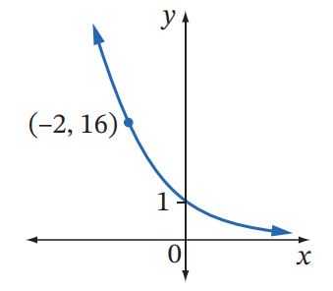
- Find an equation in the form $y=a^{x}$ for this graph:

$$y=4^{-x}$$
- Consider the exponential curves $y=2^{-x}$ and $y=$ ${\left(\frac{1}{2}\right)}^{x}$
  - Sketch each graph on the same axis.
$y=2^{-x}$
$$x$$ | $$-3$$ | $$-2$$ | $$-1$$ | $$0$$ | $$1$$ | $$2$$ | $$3$$
$$y$$

$y=$ ${\left(\frac{1}{2}\right)}^{x}$
$$x$$ | $$-3$$ | $$-2$$ | $$-1$$ | $$0$$ | $$1$$ | $$2$$ | $$3$$
$$y$$

  - What do you notice?

They are the same graph

  - Rewrite these equations in the form $y=a^{x}$, where $0<a<1$.
- $y=3^{-x}$  $$y={\left(\frac{1}{3}\right)}^{x}$$ | - $y=5^{-x}$  $$y={\left(\frac{1}{5}\right)}^{x}$$ | - $y={10}^{-x}$  $$y={\left(\frac{1}{10}\right)}^{x}$$

  - Write these rules in the form $y=a^{-x}$, where $a>1$.
- $y=$ ${\left(\frac{1}{4}\right)}^{x}$  $$y=4^{-x}$$ | - $y=$ ${\left(\frac{1}{7}\right)}^{x}$  $$y=7^{-x}$$ | - $y=$ ${\left(\frac{1}{11}\right)}^{x}$  $$y={11}^{-x}$$

Comparing Relationships

- Types of Relationships
Linear: Straight line  $$y=mx+c$$  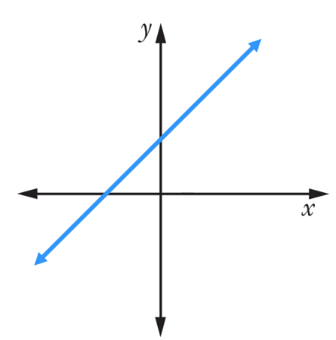 | Quadratic: Parabola  $$y=ax^{2}+bx+c$$  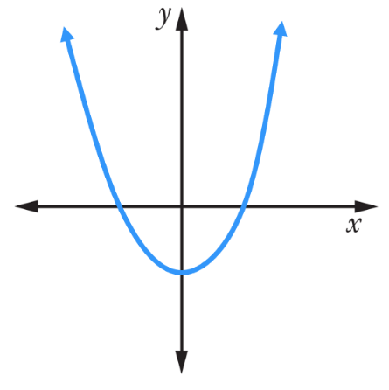 | Exponential  $$y=a^{x}$$  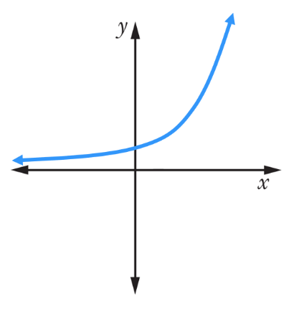

- Identify type of relationship from equation
Decide whether the following are straight lines, parabolas, or exponential curves.
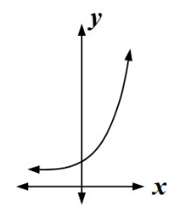 | 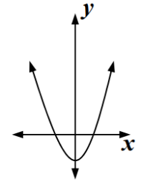 | 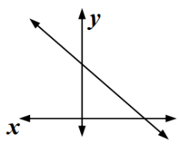
- $y=2x^{2}$ | - $y=5^{x}$ | - $y=4x+2$
- $y=-3$ | - $y=3^{x}$ | - $y=x$
- $y=x^{2}+3x-5$ | - $y=4-2x$ | - $y=-2^{x}$
- Matching equation to the curve
1. Eliminate options that are the wrong family of curves.
2. Use your knowledge of transformations.
3. If still in doubt, substitute in a point and see whether it satisfies the equation.

- Example Identify the graph from the equation
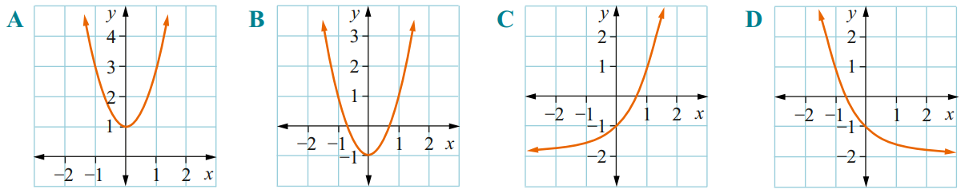
Determine which of the following could be the graph of $y=2x^{2}-1$.

1. $y=2x^{2}-1$ is a quadratic relationship, so its graph is a parabola. Eliminate $C$ and $D$.
2. $y=2x^{2}-1$ is a concave up parabola shifted downwards, so the answer is $B$.
3. Step 3 is unnecessary in this question; but we could have eliminated $A$ by substitution:
When $x=0$, $y=2{\left(0\right)}^{2}-1=-1$, so we expect a point at $\left(0,-1\right)$
Since graph $A$ has $\left(0,1\right)$, it is not our graph.

- Guided Practice
Determine which of the following could be the graph of $y=3^{-x}-2$

C
Match the equations with the graphs below:
- $y=2-x$ | - $y=2x$ | - $y=x^{2}$ | - $y=2^{x}$
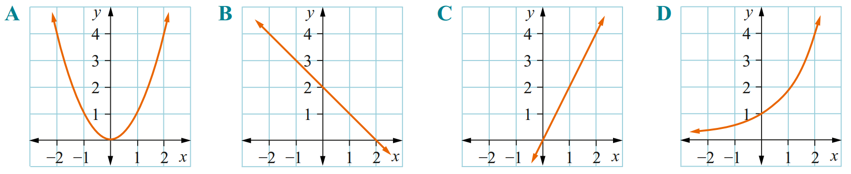

$y=x^{2}$ $y=2-x$ $y=2x$ $y=2^{x}$

Foundation
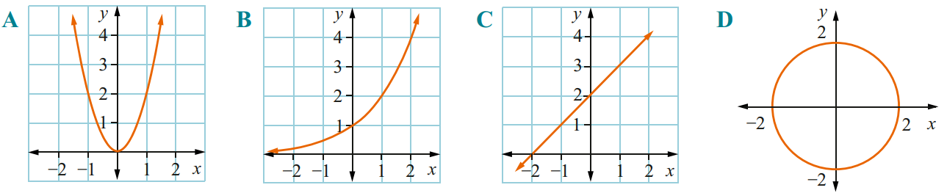
- Circle which of the following could be the graph of:
  - $y=2^{x}$

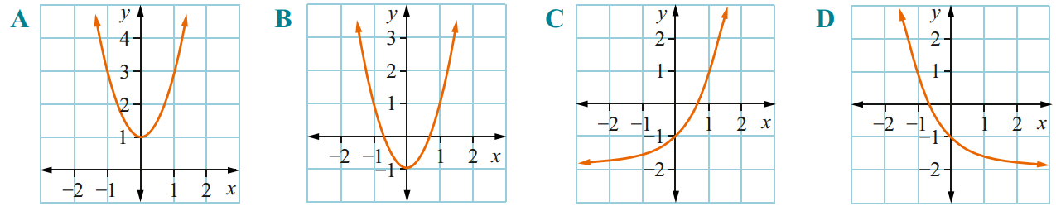
$y=2^{x}$ is exponential growth curve. B
  - $y=2x^{2}+1$

$y=2x^{2}+1$ is concave up parabola shifted upwards. A
- Match the equations with the graphs.
$y=2x^{2}$ $y=6$ $y=x+1$ $y=x$ $y=2^{-x}$
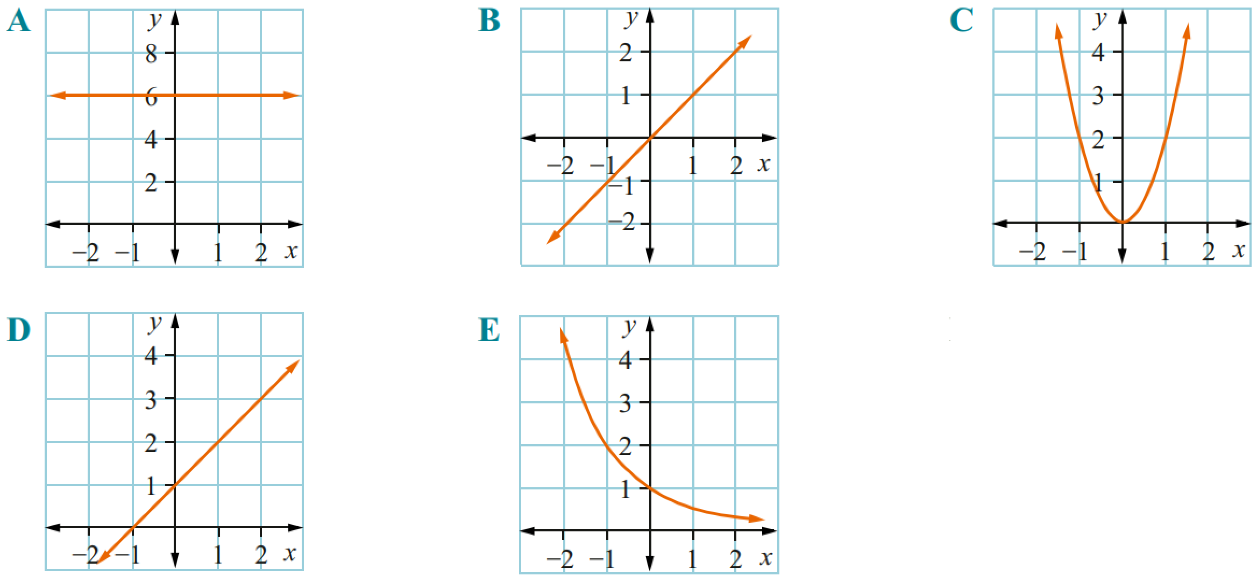  $$y=6$$ | $$y=x$$ | $$y=2x^{2}$$
$$y=x+1$$ | $$y=2^{-x}$$

Development
- Match the equations with the graphs.
$y=3^{x}$ $y=x^{2}+1$ $y=x+2$ $y=x^{2}-1$ $y=1-x^{2}$
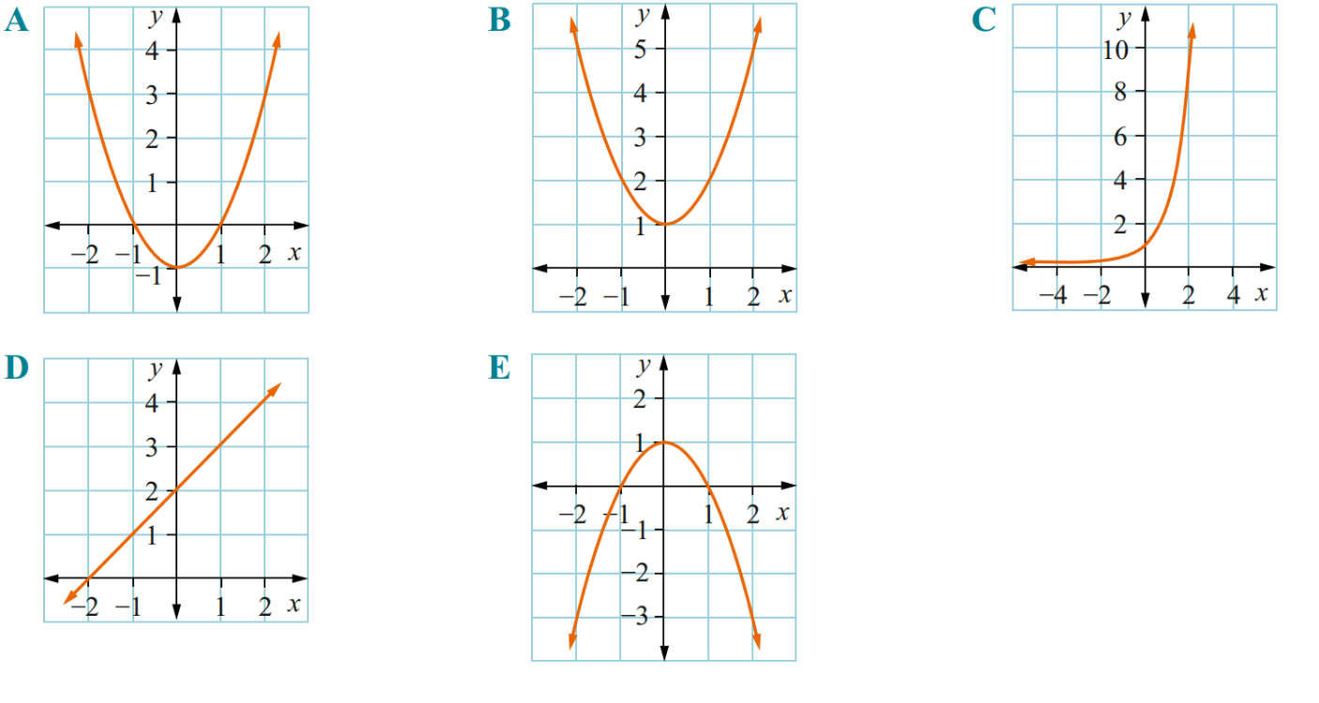  $$y=x^{2}-1$$ | $$y=x^{2}+1$$ | $$y=3^{x}$$
$$y=x+2$$ | $$y=1-x^{2}$$

- Match the equations with the graphs.
$y=3-x$ $y=-2x^{2}$ $y=4x^{2}-1$ $y=5^{-x}$ $y=3^{x}+1$
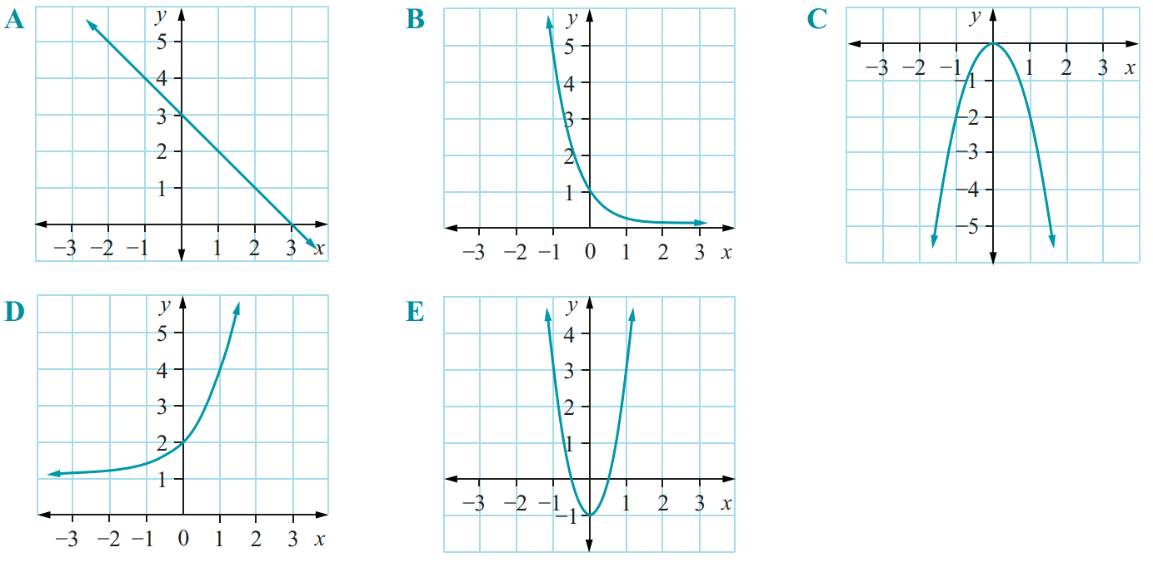  $$y=3-x$$ | $$y=5^{-x}$$ | $$y=-2x^{2}$$
$$y=3^{x}+1$$ | $$y=4x^{2}-1$$
- Match the equations with the graphs.
$y=2x-4$ $y=-3x^{2}$ $y=2x^{2}+5$ $y=-5^{-x}$ $y=5^{x}-1$
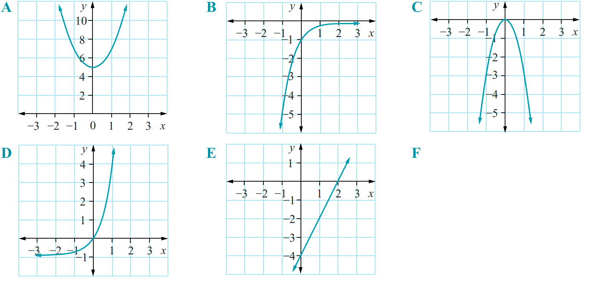  $$y=2x^{2}+5$$ | $$y=-5^{-x}$$ | $$y=-3x^{2}$$
$$y=5^{x}-1$$ | $$y=2x-4$$

- Match the equations with the graphs.
$x+2y-4=0$ $y=2x^{2}+3$ $y=-2x^{2}-3$ $y=-2^{-x}+1$ $y=-2^{x}-1$
$$y=2x^{2}+3$$ | $$y=-2^{-x}+1$$ | 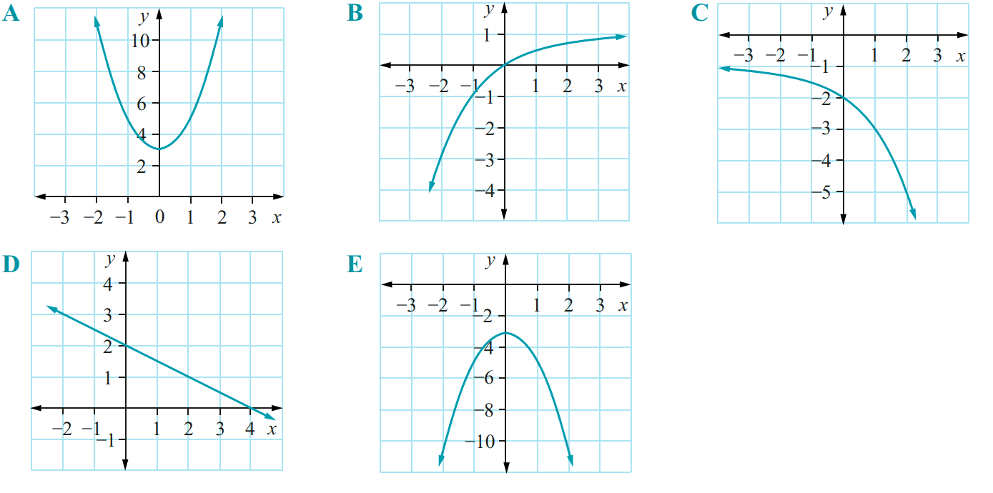  $$y=-2^{x}-1$$
$$x+2y-4=0$$ | $$y=-2x^{2}-3$$

Mastery
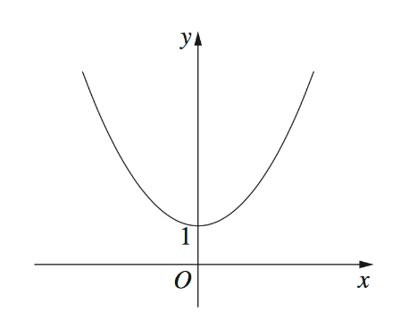
- 2014 HSC Standard 2 Band 3
Which of the following equations does the graph best represent?
- $y=\frac{3}{x}+1$
- $y=3^{x}+1$
- $y=3x^{2}+1$
- $y=3x^{3}+1$
This is a parabola. C.
- 2008 HSC Standard 2 Band 4
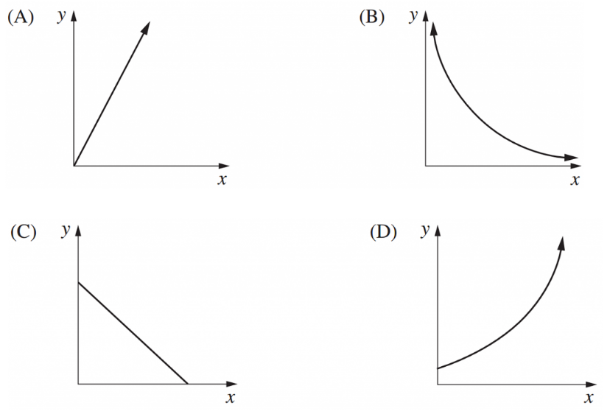
Which graph best represents $y=3^{x}$?

This is an exponential growth curve.
D
- HSC Sample Question Band 5
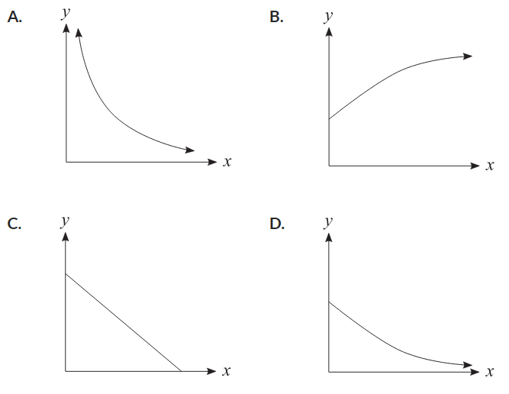
Which graph best represents $y=5^{-x}$?

This is a graph of exponential decay. Eliminate B and C.
We can eliminate $A$ by substituting $x=0$ into the equation.
$$y=5^{-0}=1$$
So, we want an exponential decay graph with point $\left(0,1\right)$
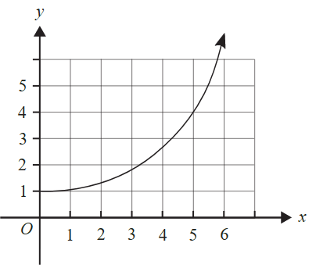
- HSC Sample Question Band 5
The graph shows $y=a^{x}$.
What is the approximate value of $2(a^{5})$?

At $x=5$ and using the graph, $y=a^{5}=4$
So $2\left(a^{5}\right)=8$

Quadratic Modelling

- Quadratic Models
A quadratic model uses a quadratic equation to show a real situation.
It finds maximum or minimum values using the turning point.

- Example Interpret a quadratic model
A girl throws a ball in the air, the ball travels upwards, then falls back down.
The height of the ball is modelled using the equation $h=-5t^{2}+25t.$
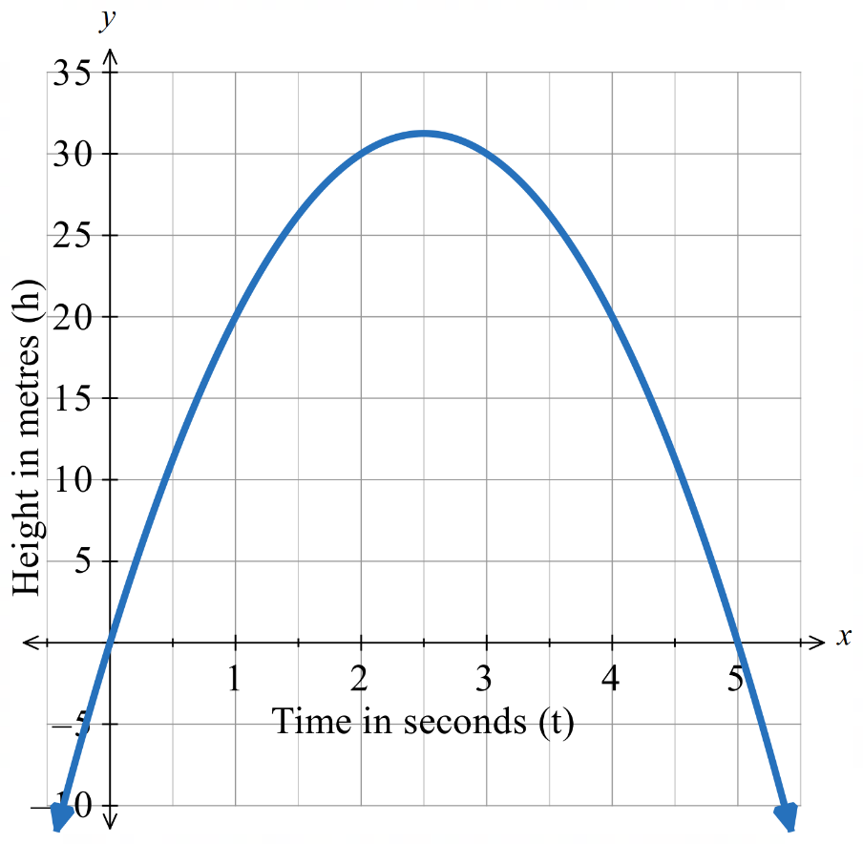
When is the ball at the maximum height? 2.5 s
Find the maximum height of the ball.
$h=-5{\left(2.5\right)}^{2}+25\left(2.5\right)=31.25$ m
At which two times is the ball 30 m high? 2 s & 3 s
At what time is the height zero? 0 s & 5 s
Calculate the height when $t=3.5$
$$h=-5{\left(3.5\right)}^{2}+25\left(3.5\right)$$
$=26.25$ m
What are the limitations of this model?
$0≤t≤5$, as time and height cannot be negative.

- Guided Practice
A rocket is launched into the air. The height of the rocket is $h=-5t^{2}+100t$,
where $h$ is height in metres and $t$ is time in seconds.
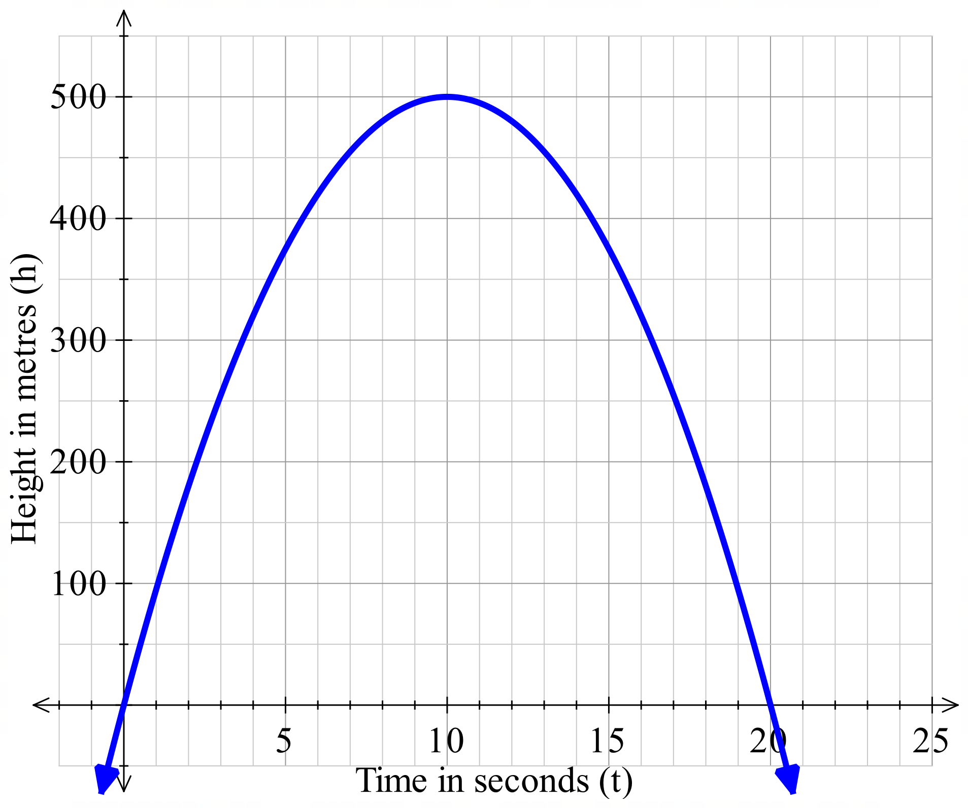
What is the maximum height and when does it occur?

500 metres at 10 seconds
At which two times is the rocket 375 m above the ground?

5 and 15 seconds
At what times is the height zero?

0 and 20 seconds
What is the height when $t=5$?

$h=-5{\left(5\right)}^{2}+100\left(5\right)=375$ m
What are the limitations of the model?

Time and height can’t be negative.
$$0≤t≤20$$

Foundation
- A ball is thrown into the air. The height of the ball, $h$, in metres, can be modelled using the quadratic equation $h=-5t^{2}+20t+1$, where $t$ is time in seconds.
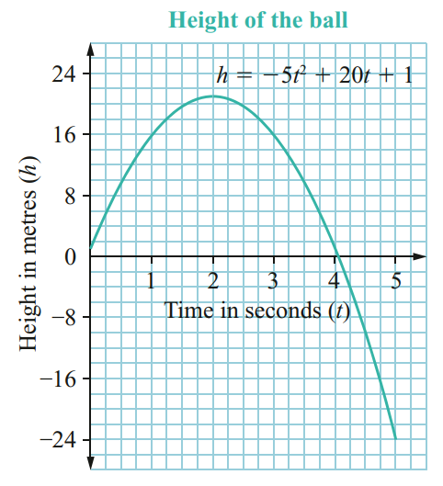
  - Find the maximum height of the ball.
21 m
  - When is the ball at its maximum height?
2 s
  - At which two times is the ball 16 m above the ground.
1 s and 3 s
  - At approximately what time is the height zero?
~4.05 s
  - What is the value of $h$ when $t=5$?
$-24$ m
  - What limitations are there on this model?

$0≤t<4$; the height can’t be negative; ball can’t go underground.
- An object is thrown into the air. The height of the object can be modelled using the equation
$h=-t^{2}+4t+5$, where $h$ is the height in metres and $t$ is the time in seconds.
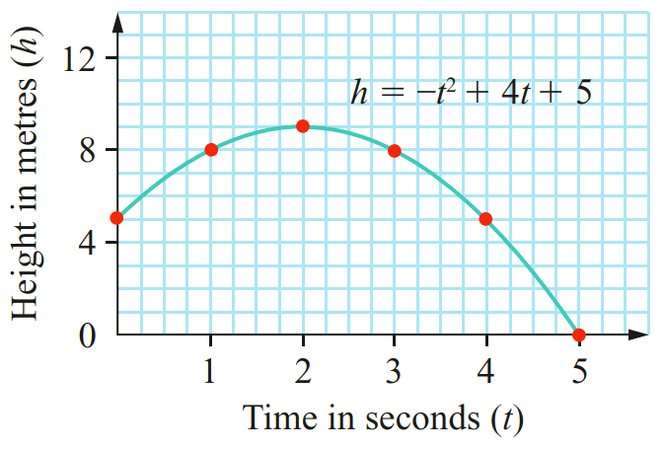
  - Find the maximum height.
When does this occur?
9 m at 2 s
  - What was the initial height of the object?
5 m
  - When does the object hit the ground?
5 s
  - Why does the graph not show the whole parabola?

Time can’t be negative and height can’t be negative.
- 2022 HSC Standard 2 Band 3
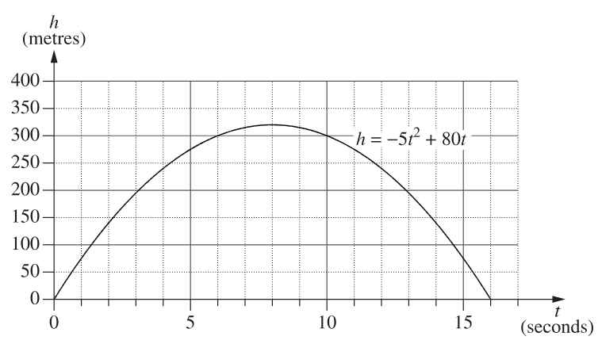
An object is projected vertically into the air. For how long is the object at a height of 300 m or more above the ground?

4 s
- Nadia is investigating stopping distances for a car travelling at different speeds.
To model this she uses the equation $d=0.01s^{2}+0.7s$, where $d$ is the stopping distance in metres and $s$ is the speed of the car in km/h. The graph of this equation is drawn on the right.
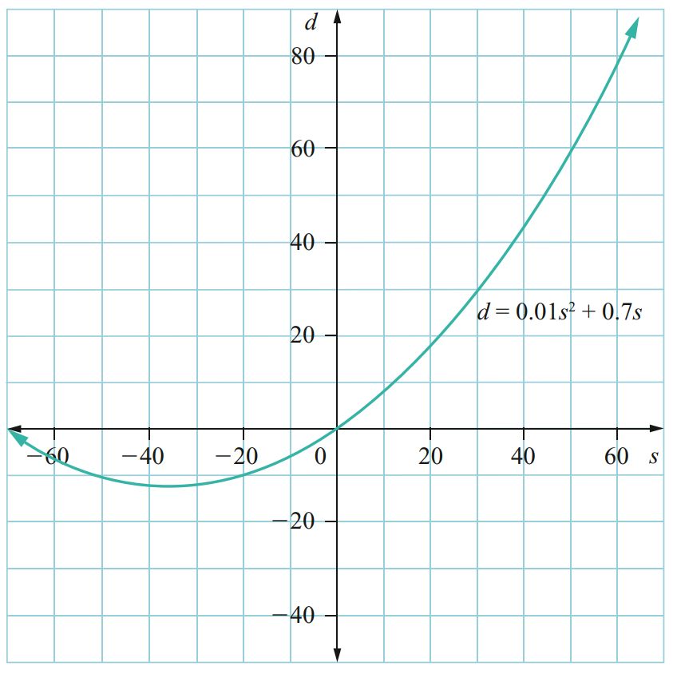
  - Nadia knows that only part of this curve applies to her model for stopping distances.
Highlight the part of this curve that applies for stopping distances.
$$s≥0$$
  - What is the difference between the stopping distances in a school zone when travelling at a speed of 40 km/h and when travelling at a speed of 60 km/h?

$≈$ 34 m
- An amateur golfer hits a ball up into the air.
The path of the ball follows the relationship $h = -d^{2}+20d$, where $h$ is the height of the ball for a horizontal distance $d$ from where the ball was hit. Both $h$ and $d$ are in metres.
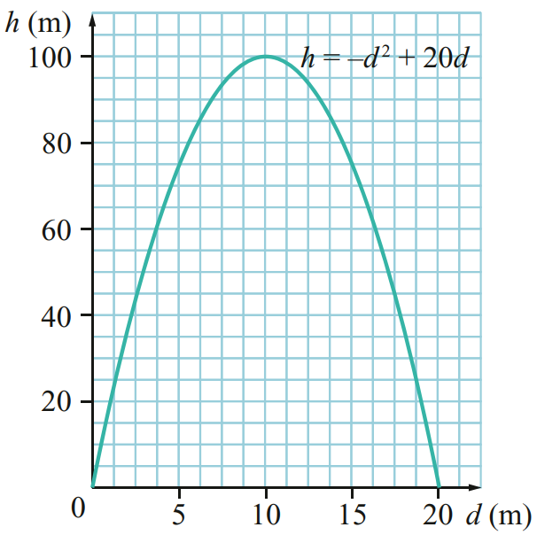
  - What was the maximum height of the golf ball?

100 m
  - How far from the golfer did the ball land?

20 m

- The height above the ground for a bungee jumper is modelled by $h=5t^{2}-40t+90$ where $h$ is the height in metres after time $t$ seconds.
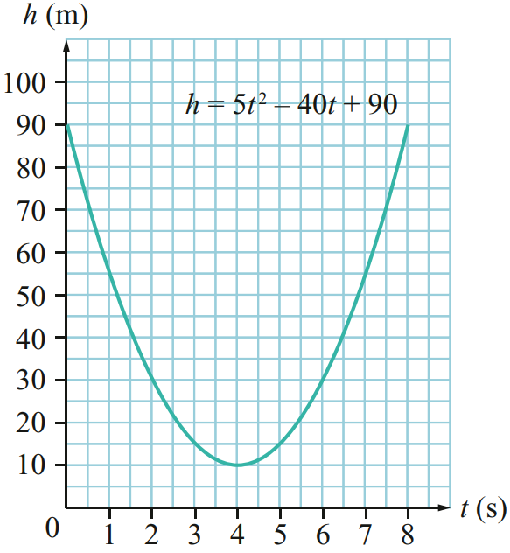
  - Use the graph to find the height of the person above the ground at the start of the jump.

90 m
  - Use the graph to find the lowest height above the ground that the person falls to in the first downwards movement of the jump.

10 m

Development
- The price ($$P$) of rope depends on the diameter ($d$), in metres, of the rope when it is rolled into a circle. The quadratic equation $P=3d^{2}$ is used to model this situation.
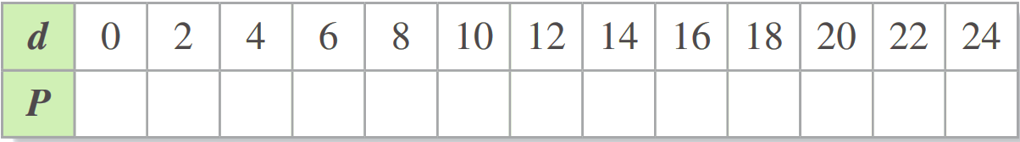
  - Fill in the table and sketch the curve.

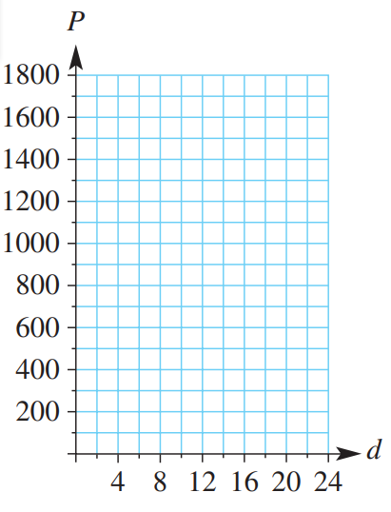
  - What is the price of the rope when the diameter of the rope is 12 metres?
$432
  - What is the price of the rope when the diameter of the rope is 23 metres?
$1587
  - What is the difference between the price of the rope when the diameter of the rope is 5 metres compared to a diameter of 15 metres?

$600
- A stone falls from rest down a mine shaft. The distance it falls, $d$ metres, at time $t$ seconds is given by the quadratic equation $d=4.9t^{2}$
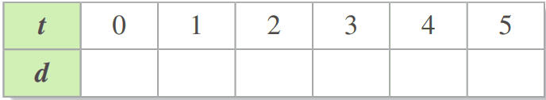
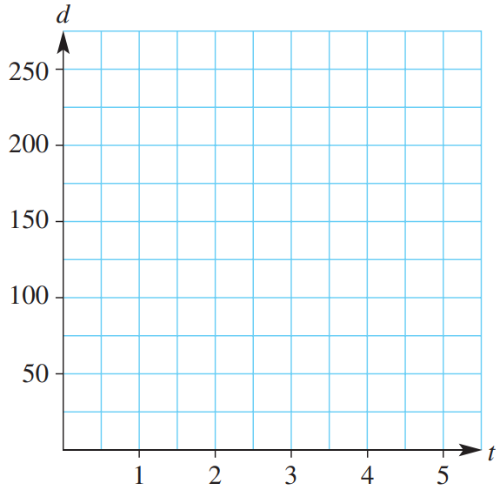
  - Fill in the table and sketch the curve.

  - What is the distance travelled by the stone after 1 second?
4.9 m
  - What is the distance travelled by the stone after 5 seconds?
122.5 m
  - What is the distance travelled by the stone after 2.5 seconds?
30.625 m
  - Use the graph to estimate how long it takes for the stone to travel 100 metres.

$≈4.5$ s
  - Use the equation to calculate how long it takes for the stone to travel 200 metres.

$≈6.4$s

Mastery
- 2017 HSC Standard 2 Band 5
A movie theatre has 200 seats. Each ticket currently costs $8.
The theatre owners are currently selling all 200 tickets for each session.
They decide to increase the price of tickets to see if they can increase the income earned from each movie session.
It is assumed that for each one dollar increase in ticket price, there will be 10 fewer tickets sold.
A graph showing the relationship between an increase in ticket price and the income is shown below.
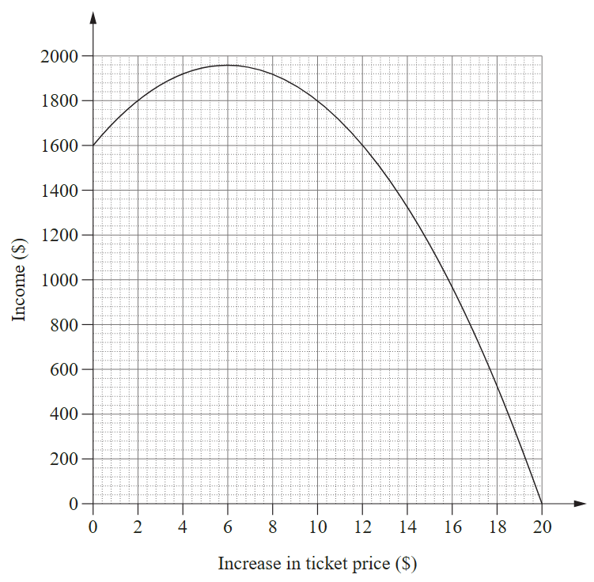
What ticket price should be charged to maximise the income from a movie session?
$8 + $6 = $14
What is the number of tickets sold when the income is maximised?
$$1960÷14=140$$
The cost to the theatre owners of running each session is $500 plus $2 per ticket sold.
Calculate the profit earned by the theatre owners when the income earned from a session is maximised.

Cost: $500+2×140=\$780$
Proft: $1960-780=\$1180$

- 2019 HSC Standard 2 Band 5
A rectangle has width $w$ centimetres. The area of the rectangle $A$ in square centimetres is
$A=2w^{2}+5w$. The graph is shown.
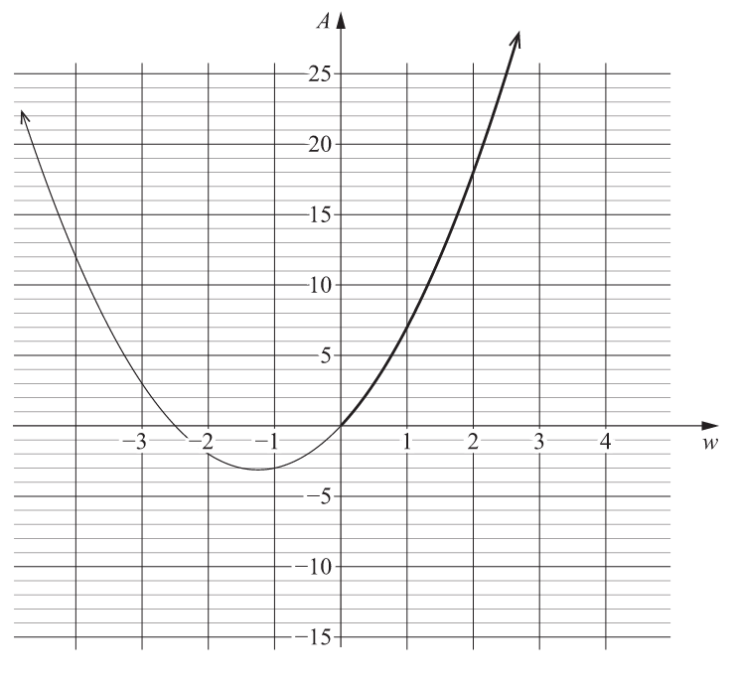
Explain why, in this context, the model only makes sense for the bold section of the graph.

Width of a rectangle can’t be negative.
The area of the rectangle is 18 cm².
Calculate the perimeter of the rectangle.

22 cm
- 2024 HSC Standard 2 Band 5
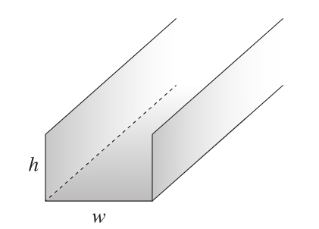
A sheet of metal is folded to make a gutter, as shown. The cross-section of the gutter is a rectangle of width $w$ cm and height $h$ cm.

The area, $A$ cm², of the cross-section can be modelled by the quadratic formula
$$A=-0.5w^{2}+20w$$
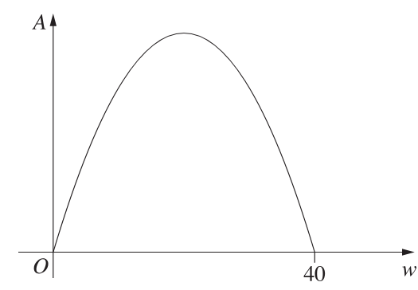
A graph of this model is shown.

Find the width and height of the rectangle which will give the greatest possible area of the cross-section.

Max area occurs at $w=20$ cm, due to symmetry of the parabola
Substitute $w=20$ into equation to get $A=200$ cm²
Since $A_{rect}=wh,$
$h=A÷w=10$ cm
$$∴w=20 cm, h=10 cm$$

- 2023 HSC Standard 2 Band 5
The braking distance of a car, $d$, in metres, is directly proportional to the square of its speed $s$ in km/h, and can be represented by the equation
$$d=ks^{2}$$
Where $k$ is the constant of variation.
The braking distance of a car travelling at 50 km/h is 20 m.
What is the braking distance when the speed of the car is 90 km/h?

  - m
- HSC Sample Question Band 4
Moses finds that for a Froghead eel, its mass is directly proportional to the square of its length.
An eel of this species has a length of 72 cm and a mass of 8250 grams.
What is the expected length of a Froghead eel with a mass of 10.2 kg?
Give your answer to one decimal place.

80.1 cm
- 2009 HSC Standard 2 Band 5
The height above the ground, in metres, of a person’s eyes varies directly with the square of the distance, in kilometres, that the person can see to the horizon.
A person whose eyes are 1.6 m above the ground can see 4.5 km out to sea.
How high above the ground, in metres, would a person’s eyes need to be to see an island that is 15 km out to sea? Give your answer correct to one decimal place.

17.8 m

Exponential Modelling

- Exponential Models
An exponential model uses an exponential equation to show a real situation.
Examples of exponential models include population growth, compound interest, declining-balance depreciation and radioactive decay.
Exponential Growth  $$y=a{\left(1+r\right)}^{x}$$  Initial value % increase per period  as a decimal | Exponential Decay  $$y=a{\left(1-r\right)}^{x}$$  Initial value % decrease per period  as a decimal

- Interpret exponential model from the equation
In each model, identify initial value, growth or decay, and increase/decrease per period.
- $y=20{\left(1+0.1\right)}^{x}$  Initial value: 20  Growth Decay  Change per period: +10% | - $y=40{\left(1+0.2\right)}^{x}$  Initial value:  Growth Decay  Change per period: | - $y=40{\left(1-0.2\right)}^{x}$  Initial value:  Growth Decay  Change per period:
- $y=35{\left(1+0.5\right)}^{x}$  Initial value:  Growth Decay  Change per period: | - $y=1400{\left(1-0.32\right)}^{x}$  Initial value:  Growth Decay  Change per period: | - $y=7600{\left(1-0.44\right)}^{x}$  Initial value:  Growth Decay  Change per period:
- $y=3500{\left(1.12\right)}^{x}$  Initial value:  Growth Decay  Change per period: | - $y=2300{\left(1.72\right)}^{x}$  Initial value:  Growth Decay  Change per period: | - $y=180{\left(0.8\right)}^{x}$  Initial value:  Growth Decay  Change per period:
- $y=800{\left(0.6\right)}^{x}$  Initial value:  Growth Decay  Change per period: | - $y=1240{\left(0.65\right)}^{x}$  Initial value:  Growth Decay  Change per period: | - $y=5000{\left(1.175\right)}^{x}$  Initial value:  Growth Decay  Change per period:

- Example Interpret an exponential model
The population of an island is modelled using the equation $P=5000{\left(1.09\right)}^{t}$ where $P$ is the population and $t$ is the time in years.
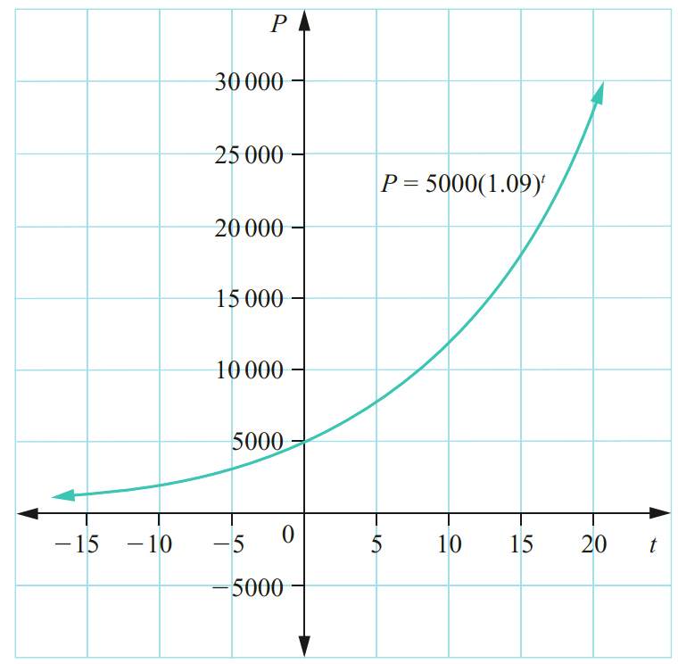
What are the limitations of the model?
$t≥0$; time cannot be negative.
Growth is also unlikely to continue exponentially for
long periods of time.

How is the population changing each year?
Increasing by 9%
What was the initial population?
$at t=0, P=5000$
Use the graph to estimate population after 10 years.
$at t=10, P≈ 12000$
Use the equation to calculate the population after 10 years.
$P=5000{\left(1.09\right)}^{10}=11836.82$
Use the graph to estimate when the population reaches 20 000. Around 16 years.

- Guided Practice
The population of a town is $P=2000{\left(1.05\right)}^{t}$ where $P$ is the population and $t$ is in years.
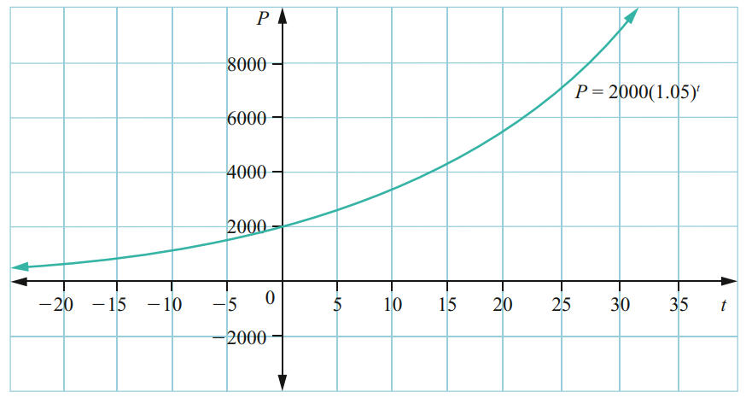
What was the initial population?
2000
Estimate the population after 25 years.

Around 7000
Calculate the population after 25 years
using the equation.
6773
How long did it take the population to double?

Population doubled to 4000 after around 13 years

What is the percentage growth each year?

5%

Foundation
- The equation $m=1.5{\left(1.2\right)}^{x}$ can be used to model the mass of a baby orangutan up to 6 months of age, where $m$ is the mass in kilograms and$x$ is the age in months.
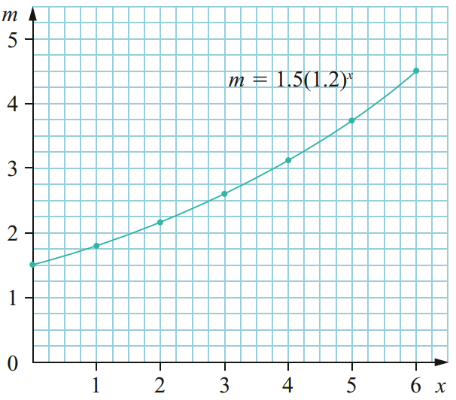
  - Estimate the mass of the orangutan at age 3.5 months.

$≈2.8$ kg
  - At about what age would the orangutan weigh 3.4 kg?

$≈$ 4.5 months
  - Each month, the mass increases by a factor of 1.2. What is the monthly growth rate of the baby orangutan’s mass? Write your answer as a percentage.

20%
  - Why might this model only be useful up to age 6 months?

Growth rate of an orangutan might speed up or slow down after 6 months.
- The population of an island is modelled using the equation $P=30 000{\left(1.02\right)}^{t}$, where $P$ is the population and $t$ is the time in years.
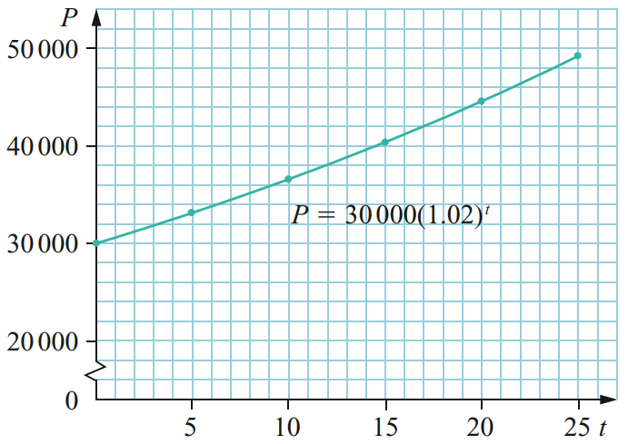
  - What does the intercept of the curve with the vertical axis represent?

Initial population
  - Use the graph to estimate the population after 18 years.

$$≈43 000$$
  - Estimate the time taken for the population to reach 39 000.

$≈$ 14 months
  - What is the percentage increase in population each year?
Explain how you can work this out from looking at the equation $P=30 000{\left(1.02\right)}^{t}$

1.02 means an increase of 2%
- Radioactive decay is a physical phenomenon that can be modelled using an exponential relationship. A piece of radioactive material decays according to the equation $m = 800{\left(0.95\right)}^{t}$ , where $m$ is the mass of radioactive substance in grams and $t$ is the number of years.
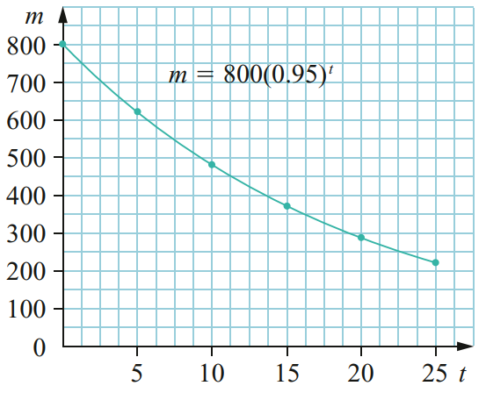
  - Explain how we can see that this model represents exponential decay.

The graph is decreasing; the equation has a base that is less than 1: 0.95.
  - What was the initial mass of radioactive material?
800 g
  - Use the graph to estimate the mass of radioactive substance after 22.5 years.

$≈$ 250 g
  - Estimate the time taken for the mass of radioactive substance to reach 600 g.

$≈$6 years
  - What is the percentage rate of decay each year?
Explain how you can work this out from looking at the equation $m = 800{\left(0.95\right)}^{t}$

0.95 means 5% decrease.
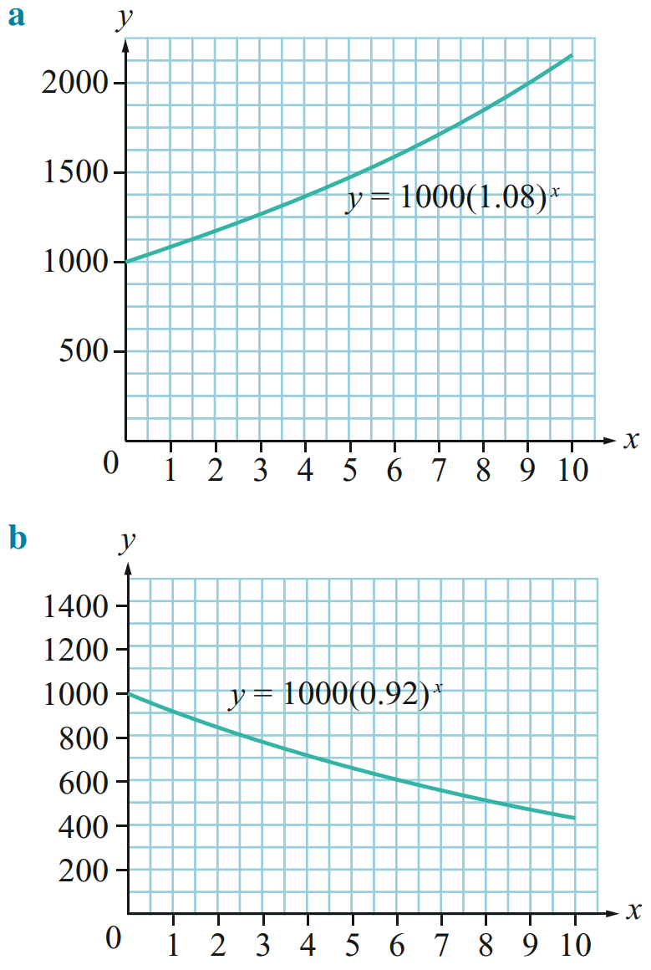
- The two graphs $y=1000{\left(1.08\right)}^{x}$ and $y=1000{\left(0.92\right)}^{x}$ are shown.

  - Which of these graphs would be used to model depreciation? How do you know?
Second graph, shows exponential decay.
  - Which of these graphs would be used to model inflation? How do you know?
First graph, shows exponential growth.
  - What would be the difference in the value of two items after 8 years, if both were purchased for $1000 and one appreciated at 8% p.a. and the other depreciated at 8% p.a.?
$$≈\$1300$$
- A new motorcycle is purchased for $20 000 and depreciates in value at a rate of 25% per year. The salvage value of the motorcycle can be modelled using the equation $S=20 000{\left(0.75\right)}^{n}$
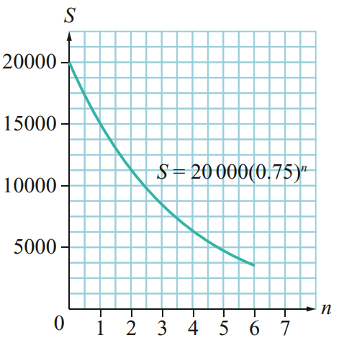
  - Does this graph represent exponential growth or decay?

Decay.
  - What does the intercept of the curve with the vertical axis represent?

Initial value of the motorcycle.
  - Use the graph to find the salvage value of the motorcycle after 2 years.

$$≈\$11 250$$
  - From the graph, estimate the number of years it takes for the salvage value of the motorcycle to be less than $6000.

$≈$ 4 years
- The compound interest formula is $FV=PV{\left(1 + r\right)}^{n}.$ The graph of a compound interest investment is shown.
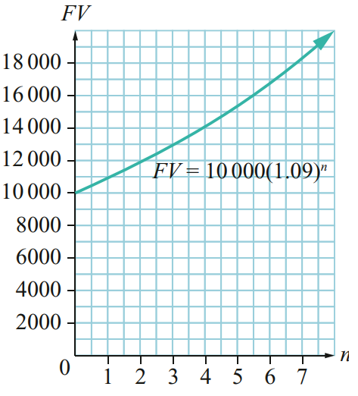
  - Looking at the equation of the graph, what was the present value of the investment?

$10 000
  - Looking at the equation of the graph, what is the percentage interest rate per period?

9% increase
  - Estimate the time it takes for the future value to grow to 14 000.

$≈$ 4 years
  - Estimate the future value after 7 years using the graph, then check using the equation.

$$\$18 280.39$$

Development
- The formula for declining balance depreciation is $S=V_{0}{\left(1-r\right)}^{n}$. The graph of a declining balance depreciation is shown.
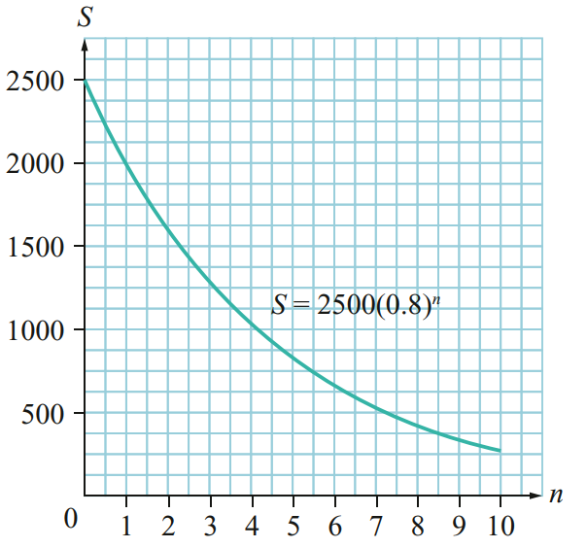
  - Looking at the equation of the graph, what was the initial value of the investment?

$2500
  - Looking at the equation of the graph, what is the percentage depreciation rate per period?

20%
  - Estimate the time it takes for the salvage value to reach $500.

$≈$7 years
  - Estimate the salvage value after 3 years using the graph and check using the equation.

$$\$1280$$
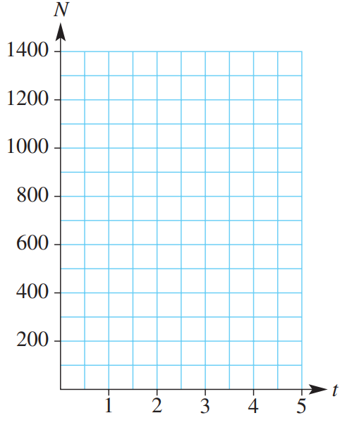
- The exponential function, $N=6^{t}$ is used to model the growth in the number of insects (N) after t days.
  - Fill in the table and sketch the curve.
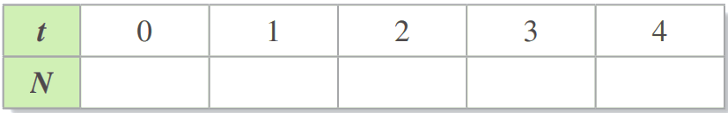

  - What was the initial number of insects?

1
  - How many insects were present after 3 days?

216
  - How many extra insects will be present after 4 days
compared to 2 days?

1260
  - Estimate how many days it took for the number of insects to exceed 1000.
Answer to the nearest 1 d.p.

$≈$ 3.9 days

Mastery
- 2021 HSC Standard 2 Band 5
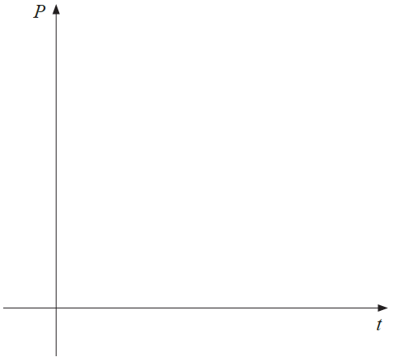
A population $P$ is to be modelled using the function $P=2000{\left(1.2\right)}^{t}$ where $t$ is the time in years.
What is the initial population?

2000
Find the population after 5 years. Answer to the nearest whole.

4977
On the axes, sketch the population against time,
showing the points at $t=0$ and $t=5$

Exponential growth curve with points (0, 2000) and (5, 4977)
- 2016 HSC Standard 2 Band 5
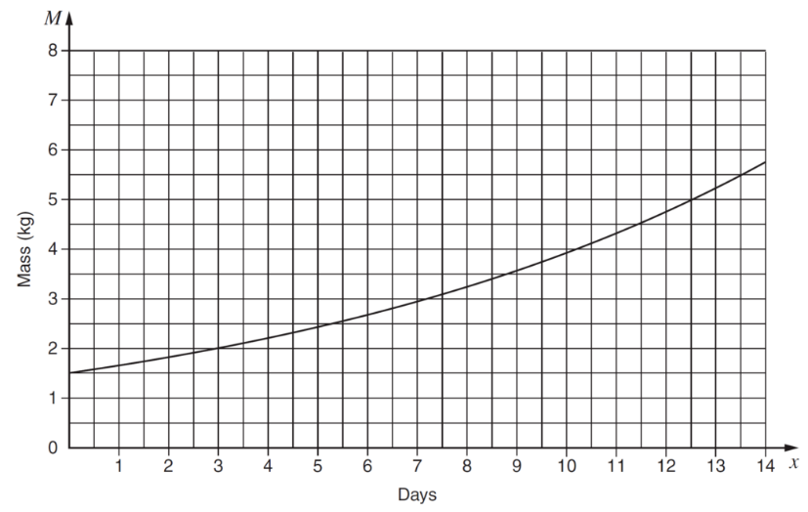
The mass of a baby pig at age $x$ days is given by $M=A{\left(1.1\right)}^{x}$ where $A$ is a constant.
The graph is shown.
What is the value of $A$?

1.5
What is the daily growth rate of the pig’s mass?
Write your answer as a percentage.

10%

- 2020 HSC Standard 2 Band 6
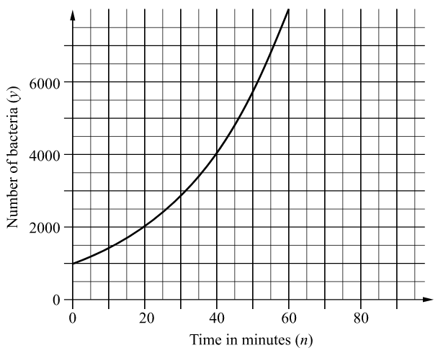
The graph shows the number of bacteria $y$ at time $t$ minutes. Initially, when $n=0$, the number of bacteria is 1000.
Find the number of bacteria at 40 minutes.

4000
The number of bacteria can be modelled by $A×b^{n}$ where $A$ and $b$ are constants.
Use guess and check to find, to two decimal places, an upper and lower estimate for the value of $b$. The upper and lower estimates must differ by 0.01.

We want to find a value of $b$ such that $1000×b^{40}≈4000$
$$1.03<b<1.04$$

